**Practical File**

**Name:**  Chandni Yadav

**Roll no.:**  21/BS(G)MS/11741

**Course:**  B.Sc. Mathematical Sciences

**Year/Semester:** 3rd/ 6th

**Paper Name:**  Integer Programming and

                         Theory of Games

**Submitted To:**  Dr. Rubina Mittal &

      Dr. Mohammed Shahid Irshad

**INDEX**

|  |  |
| --- | --- |
| **S. No.** | **Questions** |
| **1.** | The owner of a readymade garment store sells two types of shirts Zee shirts and button-down shirts. He makes a profit of $3 on zee shirts and $12 on button down shirts. He has two tailor A & tailor B at his disposal to stitch the shirts. Tailor A can devote 7 hours and tailor B can devote 15 hours at most per day. Both these shirts need to be stitched by both tailors. Tailor A and tailor B take 2 & 5 hours on zee shirts and 4 & 3 hours on button shirts respectively. How many of shirts of both types should be stitched to maximize daily profit. Formulate and solve this as LP problem and if the solution is not integer value, derive the optimal integer problem. |
| **2.** | The XYZ Company produces two types of tape recorders: A reel-to-reel model and a cassette model on two assembly lines. The company must process each tape recorder on each assembly line and it has found that the following time is required:   |  |  |  | | --- | --- | --- | | Assembly line | Reel-to-reel | Cassette | | 1 | 6 hours | 2 hours | | 2 | 3 hours | 2 hours |   The production manager says that line 1 will be available 40 hours per week and line 2 only 30 hours. After these hours of operation each line must be checked for repairs. The company realizes a profit of Rs 300 on each reel-to-reel recorder and Rs 120 on each cassette recorder. Formulate and solve this problem as an integer LP problem to determine the number of recorders of each type to be produced each week in order to maximize profit. |
| **3.** | Solve Q2 using Gomory’s cutting plane method. |
| **4.** | ABC manufacturing company faces the following problem: Should they make or buy each of their several products? The company policies specify that they will either make or buy the whole lot of each product in a complete lot. The company has four products to make or buy with six machines involved in making these products if they are made in the shop. The time per unit (in hours) required are as follows:   |  |  |  |  |  |  |  | | --- | --- | --- | --- | --- | --- | --- | | Product | Machine | | | | | | | A | B | C | D | E | F | | 1 | 0.04 | 0.02 | 0.02 | 0 | 0.03 | 0.06 | | 2 | 0 | 0.01 | 0.05 | 0.15 | 0.09 | 0.06 | | 3 | 0.02 | 0.06 | 0 | 0.06 | 0.02 | 0.02 | | 4 | 0.06 | 0.04 | 0.15 | 0 | 0 | 0.05 |   Forty hours are available of each machine. One hundred ten units of each product are needed. The costs of making the products are listed below:   |  |  |  |  |  | | --- | --- | --- | --- | --- | | Products: | 1 | 2 | 3 | 4 | | Cost/unit (in Rs.): | 2.25 | 2.22 | 4.50 | 1.90 |   The costs to buy the products are:   |  |  |  |  |  | | --- | --- | --- | --- | --- | | Products: | 1 | 2 | 3 | 4 | | Cost/unit (in Rs.): | 3.10 | 2.60 | 4.75 | 2.25 |   Formulate this problem as a zero-one integer programming problem. |
| **5.** | Consider the following production data:   |  |  |  |  |  | | --- | --- | --- | --- | --- | | **Product** | **Profit Per Unit (Rs.)** | | **Direct Labor Requirement (in Hours)** | | | 1 | 8 | | 15 | | | 2 | 10 | | 14 | | | 3 | 7 | | 17 | | | **Fixed Cost** | | **Direct Labor Requirement** | | | 10,000 | | Up to 20,000 hours | | | 20,000 | | 20,000-40,000 hours | | | 30,000 | | 40,000-70,000 hours | |   Formulate an integer programming problem to determine the production schedule so as to maximize the total net profit. |
| **6.** | Solve the following problem for profit maximization:   |  |  |  |  |  |  |  |  | | --- | --- | --- | --- | --- | --- | --- | --- | | **Model** | **Quantity** | **Plant A** | **Plant B** | **Plant C** | **Capacity** | **Selling Price** | **Plant** | | **Standard** | 450 | 8 | 7.95 | 8.10 | 800 | 14.95 | A | | **Deluxe** | 1050 | 8.50 | 8.60 | 8.45 | 600 | 18.85 | B | | **New Deluxe** | 600 | 9.25 | 9.20 | 9.30 | 700 | 21.95 | C | |
| **7.** | Find the minimum cost for covering all zones:   |  |  |  |  |  |  |  | | --- | --- | --- | --- | --- | --- | --- | |  | **i** | **ii** | **iii** | **iv** | **v** | **vi** | | **A** | 73 | 91 | 87 | 82 | 78 | 80 | | **B** | 81 | 85 | 69 | 76 | 74 | 85 | | **C** | 75 | 72 | 83 | 84 | 78 | 91 | | **D** | 93 | 96 | 86 | 91 | 83 | 82 | | **E** | 90 | 91 | 79 | 89 | 89 | 76 | |
| **8.** | A manufacturer has distribution centers at Agra, Allahabad and Kolkata. These centers have availability of 40, 20 and 40 units of his product respectively. His retail outlets at A, B, C, D, E require 25, 10, 20, 30 and 15 units of the products respectively. The transport cost (in rupees) per unit between each center outlet is given below: -   |  |  |  |  |  |  | | --- | --- | --- | --- | --- | --- | | **Distribution Centre** | **Retail Outlets** | | | | | |  | **A** | **B** | **C** | **D** | **E** | | **Agra** | 55 | 30 | 40 | 50 | 40 | | **Allahabad** | 35 | 30 | 100 | 45 | 60 | | **Kolkata** | 40 | 60 | 95 | 35 | 30 |     Determine the optimal distribution so as to minimize the cost of transportation. |
| **9.** | Find minimum production cost.   |  |  |  |  |  |  | | --- | --- | --- | --- | --- | --- | |  | Jan | Feb | Mar | Apr | May | | Production cost | 24 | 27 | 32 | 50 | 34 | | Demand | 200 | 250 | 150 | 80 | 120 | | Capacity | 250 | 225 | 250 | 200 | 225 |   Inventory carrying cost: 5 per unit per month |
| **10.** | Find minimum production cost.   |  |  |  |  |  | | --- | --- | --- | --- | --- | | **Month** | **Max Production** | **Demand** | **Production Cost** | **Inventory Cost** | | **Jan** | 120 | 100 | 60 | 15 | | **Feb** | 120 | 130 | 60 | 15 | | **March** | 150 | 160 | 55 | 20 | | **April** | 150 | 160 | 55 | 20 | | **May** | 150 | 140 | 50 | 20 | | **June** | 150 | 140 | 50 | 20 | |
| **11.** | ABC Company wishes to develop a monthly production schedule for the next three months depending upon the sales commitments, the company can keep the production constant, allowing fluctuations in inventory or inventories can be maintained at constant level, with fluctuating production. Fluctuating production necessitates, working overtime, the cost of which is estimated to be double the normal production cost of 12 Rupee per unit. Fluctuating inventories result in inventory carrying of 2 Rupee per unit per month. If the company fails to fulfill its sales commitment it incurs a shortage cost of 4 Rupee per unit per month. The production capacities for the next three month are shown in table: -**Production Capacity**   |  |  |  |  | | --- | --- | --- | --- | | Month | Regular | Overtime | Sales | | 1 | 50 | 30 | 60 | | 2 | 50 | 0 | 120 | | 3 | 60 | 50 | 40 |   Determine optimal production schedule. |
| **12.** | Consider the game with the following payoff table:   |  |  |  | | --- | --- | --- | |  | Player B | | | Player A | B1 | B2 | | A1 | 2 | 6 | | A2 | -2 |  |     i)                  Show that the game is strictly determinable, whatever λ may be.  ii)                 Determine the value of the game. |
| **13.** | Determine which of the following two-person zero sum games are strictly determinable and fair. Give the optimum strategies for each player in the case of strictly determinable.   |  |  |  | | --- | --- | --- | |  | Player B | | | Player A | B1 | B2 | | A1 | 1 | 2 | | A2 | 4 | -3 |   b)   |  |  |  | | --- | --- | --- | |  | Player B | | | Player A | B1 | B2 | | A1 | -5 | 2 | | A2 | -7 | -4 | |
| **14.** | Solve the following game by using maximin(minimax) principle whose payoff matrix are given below: Include in your answer:   1. Strategy selection for each player 2. The value of the game to each player   Does the game have saddle point?   |  |  |  |  |  | | --- | --- | --- | --- | --- | |  | Player B | | | | | Player A | B1 | B2 | B3 | B4 | | A1 | 1 | 7 | 3 | 4 | | A2 | 5 | 6 | 4 | 5 | | A3 | 7 | 2 | 0 | 3 | |
| **15.** | Solve the following game by using maximin(minimax) principle whose payoff matrix are given below: Include in your answer:   1. Strategy selection for each player 2. The value of the game to each player  |  |  |  |  |  |  | | --- | --- | --- | --- | --- | --- | |  | Player B | | | | | | Player A | B1 | B2 | B3 | B4 | B5 | | A1 | -2 | 0 | 0 | 5 | 3 | | A2 | 3 | 2 | 1 | 2 | 2 | | A3 | -4 | -3 | 0 | -2 | 6 | | A4 | 5 | 3 | -4 | 2 | 6 | |
| **16.** | Solve the following game by using maximin(minimax) principle whose payoff matrix are given below: Include in your answer:   1. Strategy selection for each player 2. The value of the game to each player   Does the game have saddle point?   |  |  |  |  |  | | --- | --- | --- | --- | --- | |  | Player B | | | | | Player A | B1 | B2 | B3 | B4 | | A1 | 3 | -5 | 0 | 6 | | A2 | -4 | -2 | 1 | 2 | | A3 | 5 | 4 | 2 | 3 | |
| **17.** | Solve the following game by using maximin(minimax) principle whose payoff matrix are given below: Include in your answer:   1. Strategy selection for each player 2. The value of the game to each player  |  |  |  |  | | --- | --- | --- | --- | |  | Player B | | | | Player A | B1 | B2 | B3 | | A1 | -2 | 15 | -2 | | A2 | -5 | -6 | -4 | | A3 | -5 | 20 | -8 | |
| **18.** | Solve the following game by using maximin(minimax) principle whose payoff matrix are given below: Include in your answer:   1. Strategy selection for each player 2. The value of the game to each player   Does the game have saddle point?   |  |  |  |  |  | | --- | --- | --- | --- | --- | |  | Player B | | | | | Player A | B1 | B2 | B3 | B4 | | A1 | -5 | 3 | 1 | 10 | | A2 | 5 | 5 | 4 | 6 | | A3 | 4 | -2 | 0 | -5 | |
| **19.** | Two competitive manufacturers are producing a new toy under license from a patent holder. In order to meet the demand, they have the option of running the plant for 8, 16 or 24 hours a day. As the length of production increases so does the cost. One of the manufacturers, say A, has set up the matrix given below. He uses the matrix to estimate the percentage of the market that he could capture and maintain the different production schedules:   |  |  |  |  | | --- | --- | --- | --- | |  | Manufacturer B | | | | Manufacturer A | C1: 8 hrs. | C2:16 hrs. | C3:24 hrs. | | S1:8 hrs. | 60% | 56% | 34% | | S2:16 hrs. | 63% | 60% | 55% | | S3:24 hrs. | 83% | 72% | 60% | |
| **20.** | Solve graphically, the rectangular game, whose payoff matrix is:   |  |  |  |  |  | | --- | --- | --- | --- | --- | |  | Player B | | | | | Player A | B1 | B2 | B3 | B4 | | A1 | 2 | 1 | 0 | -2 | | A2 | 1 | 0 | 3 | 2 | |
| **21.** | Solve graphically, the rectangular game, whose payoff matrix is:   |  |  |  | | --- | --- | --- | |  | Player B | | | Player A | B1 | B2 | | A1 | 1 | -3 | | A2 | 3 | 5 | | A3 | -1 | 6 | | A4 | 4 | 1 | | A5 | 2 | 2 | | A6 | -5 | 0 | |
| **22.** | Solve graphically, the rectangular game, whose payoff matrix is:   |  |  |  |  |  | | --- | --- | --- | --- | --- | |  | Player B | | | | | Player A | B1 | B2 | B3 | B4 | | A1 | 6 | 5 | 2 | 3 | | A2 | 1 | 2 | 6 | 3 | |
| **23.** | Solve graphically, the rectangular game, whose payoff matrix is:   |  |  |  |  |  | | --- | --- | --- | --- | --- | |  | Player B | | | | | Player A | B1 | B2 | B3 | B4 | | A1 | 3 | 1 | 0 | -2 | | A2 | 1 | 0 | 3 | 2 | |
| **24.** | Two computer manufacturers A and B are attempting to sell computer systems to two banks 1 and 2. Company A has 4 salesmen; company B only has 3 salesmen available. The computer companies must decide upon how many salesmen to assign to sell computer to each bank. Thus, company A can assign 4 salesmen to bank 1 and none to bank 2 or three to bank 1 and one to bank 2, etc.  Each bank will buy one computer system. The probability that a bank will buy from a particular computer company is directly related to the number of salesmen calling from that company, relative to the total salesmen calling. Thus, if company A assigns three salesmen to bank 1 and company B assigns two salesmen, the odds would be three out of five that bank 1 would purchase company A’s computer system. (If none calls from either company the odds are one-half for buying either computer.)  Let the payoff be the expected number of computer systems that company A sells. (2 minus this payoff is the expected number company B sells).  What strategy would company A use in allocating its salesmen? What strategy should company B use? What is the value of the game to company A? What is the meaning of the value of the game in this problem? |
| **25.** | The firms A and B have for years been selling’s a competitive product which forms a part of both firms’ total sales. The marketing executive of firm A raised the question, “What should be the firm’s strategies in terms of advertising product in question?” The market research team of firm A developed the following data for varying degrees of advertising:   1. No advertising, medium advertising, and large advertising for both firms will result in equal market shares. 2. Firm A with no advertising: 40% of market with medium advertising by firm B and 28% of the market with large advertising by firm B 3. Firm A using medium advertising: 70% of the market with no advertising by firm B and 45% of the market with large advertising by firm B 4. Firm A using large advertising: 75% of the market with no advertising by firm B and 47.5% of the market with medium advertising by firm B 5. Based upon their foregoing information, answer the marketing executive’s questions. 6. What advertising policy should firm A pursue when consideration is given to the above factors: selling price Rs. 4 per unit: variable cost of product Rs. 2.5 per unit; annual volume of 30,000 units for firm A; cost of annual medium advertising Rs. 5,000 and cost of annual large advertising Rs. 15,000? What contribution before other fixed costs is available to the firm? |
| **26.** | Solve the given payoff matrix. Transfer the zero sum two-person game into equivalent linear programming problem. Solve using Simplex Method.   |  |  |  |  | | --- | --- | --- | --- | |  | **B1** | **B2** | **B3** | | **A1** | **5** | **3** | **7** | | **A2** | **7** | **9** | **1** | | **A3** | **10** | **6** | **2** | |
| **27.** | For the following payoff matrix, transform the zero sum two-person game into an equivalent linear programming problem and solve it by simplex method.   |  |  |  |  | | --- | --- | --- | --- | |  | Player B | | | | Player A | B1 | B2 | B3 | | A1 | 9 | 1 | 4 | | A2 | 0 | 6 | 3 | | A3 | 5 | 2 | 8 | |
| **28.** | For the following payoff matrix, transform the zero sum two-person game into an equivalent linear programming problem and solve it by simplex method.   |  |  |  |  | | --- | --- | --- | --- | |  | Company A | | | | Company B | A1 | A2 | A3 | | B1 | 2 | -2 | 3 | | B2 | -3 | 5 | -1 | |
| **29.** | A soft drink company calculated the market share of two of its products against its major competitor, which has three products. The company found out the impact of additional advertisement in any one of its products against the other.   |  |  |  |  | | --- | --- | --- | --- | |  | Company B | | | | Company A | B1 | B2 | B3 | | A1 | 6 | 7 | 15 | | A2 | 20 | 12 | 10 |   What is the best strategy for the company as well as the competitor? What is the payoff obtained by the company and the competitor in the long run? Use the graphical method to obtain the solution. |
| **30.** | Two Firms A and B make color and black & white television sets. Firm A can make either 150 color sets in a week or an equal number of black and white sets, and make a profit of Rs 400 per color set and Rs 300 per black & white set. Firm B can, on the other hand, make either 300 color sets, or 150 color and 150 black & white sets, or 300 black & white sets per week. It also has the same profit margin on the two sets as A. Each week there is a market of 150 color sets and 300 black & white sets. The manufacturers would share market depending upon the proportion in which they manufacture a particular type of set.  Write the payoff matrix of A per week. Obtain, graphically, A’s and B’s optimal strategies and the value of the game. |
| **31.** | In a town there are only two discount stores ABC and XYZ. Both stores run annual pre-Diwali sales. Sales are advertised through local newspapers with the aid of an advertising firm. ABC stores constructed following payoff in units of Rs 1,00,000. Find the optimal strategies for both stores and the value of the game:   |  |  |  |  | | --- | --- | --- | --- | |  | Store XYZ | | | | Store ABC | B1 | B2 | B3 | | A1 | 1 | -2 | 1 | | A2 | -1 | 3 | 2 | | A3 | -1 | -2 | 3 | |
| **32.** | Assume that the two firms are competing for market share for a particular product. Each firm is considering what promotional strategy to employ for the coming period. Assume that the following payoff matrix describes the increase in market share for Firm A and the decrease in market share for Firm B. Determine the optimal strategies for each firm.   |  |  |  |  | | --- | --- | --- | --- | |  | Firm B | | | | Firm A | No Promotion | Moderate Promotion | Much Promotion | | No Promotion | 5 | 0 | -10 | | Moderate Promotion | 10 | 6 | 2 | | Much Promotion | 20 | 15 | 10 |   Formulate a suitable linear programming model of the game, with respect to minimizing player B's losses and derive the optimal strategy for B. |
| **33.** | Firm X is fighting for its life against the determination of firm Y to drive it out of the industry. Firm X has the choice of increasing the price, leaving it unchanged, or lowering it. Firm Y has the same three options. Firm X’s gross sales in the event of each of the pairs of choices are shown below:   |  |  |  |  | | --- | --- | --- | --- | | Firm Y’s Pricing Strategies | Firm Y’s Pricing Strategies | | | | Increase Price | Do not change | Reduce Price | | Increase Price | 90 | 80 | 110 | | Do not change | 110 | 100 | 90 | | Reduce Price | 120 | 70 | 80 |   Assuming firm X as the maximizing one, formulate and solve the problem as a linear programming problem. |

**Ques 1.**

The owner of a readymade garment store sells two types of shirts Zee shirts and button-down shirts. He makes a profit of $3 on zee shirts and $12 on button down shirts. He has two tailor A & tailor B at his disposal to stitch the shirts. Tailor A can devote 7 hours and tailor B can devote 15 hours at most per day. Both these shirts need to be stitched by both tailors. Tailor A and tailor B take 2 & 5 hours on zee shirts and 4 & 3 hours on button shirts respectively. How many of shirts of both types should be stitched to maximize daily profit. Formulate and solve this as LP problem and if the solution is not integer value, derive the optimal integer problem.

**Solution:**

Let the zee shirts be denoted by variable =

Let the button-down shirts be denoted by variable =

So, the objective function will be to maximize profit, which can be written as:

Time constraint for Tailor A:

Time constraint for Tailor B:

So, the formulated problem is:

Now solving this as an LPP in Tora, we get the following input table:

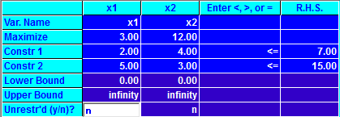

First Iteration:

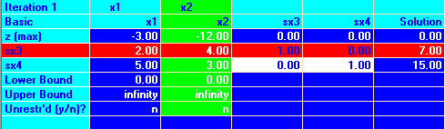

Second Iteration (Optimal):

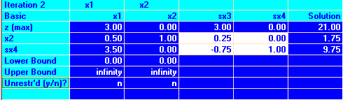

Here, we get . This gives maximum Z = 21.

Since is non-integer, we proceed with integer programming.

Input Table:

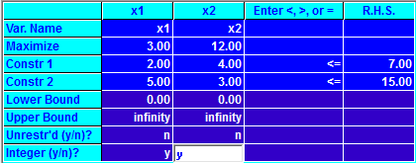

Output:

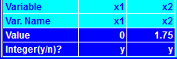

Here as well, we get the same initial solution using simplex. Now we branch since it is non integer.

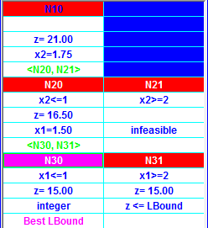

Here, in the first iteration we add two constraints for , The latter is infeasible so we proceed with . With this we get which is again non integer so in the next iteration we add two more constraints,

The best solution is then found at , Z = 15 (represented by N30 in the above picture).

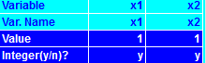

We see that there is a difference of $6 when we move from a non-integer to an integer solution.

**Final Solution:**

**For LPP:** Maximized profit = 21, if 0 zee () and 1.25 button down () shirts are made.

**For IPP:** Maximized profit = 15, if 1 zee () and 1 button down () shirts are made.

**Ques 2.**

The XYZ Company produces two types of tape recorders: A reel-to-reel model and a cassette model on two assembly lines. The company must process each tape recorder on each assembly line and it has found that the following time is required:

|  |  |  |
| --- | --- | --- |
| Assembly line | Reel-to-reel | Cassette |
| 1 | 6 hours | 2 hours |
| 2 | 3 hours | 2 hours |

The production manager says that line 1 will be available 40 hours per week and line 2 only 30 hours. After these hours of operation each line must be checked for repairs. The company realizes a profit of Rs 300 on each reel-to-reel recorder and Rs 120 on each cassette recorder. Formulate and solve this problem as an integer LP problem to determine the number of recorders of each type to be produced each week in order to maximize profit.

**Solution:**

Let the reel-to-reel recorders be denoted by variable =

Let the cassette recorders be denoted by variable =

So, the objective function will be to maximize profit, which can be written as:

Time constraint for line 1:

Time constraint for line 2:

So, the formulated problem is:

Now solving this problem in Tora, we get the following input table:

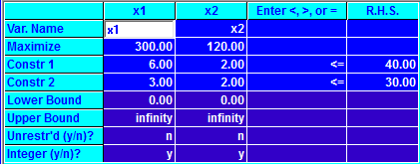

Output:

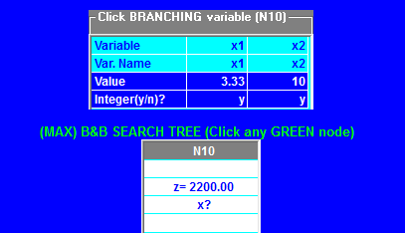

Here, the initial solution that we get is Z = 2200 at . Since is non integer, we proceed with integer programming.

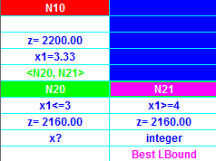

We select since it was non integer (3.33) and add two constraints in the first iteration to make two new subproblems, . We get the best integer solution at , which maximizes Z at 2160.

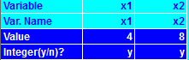

**Final Solution:** Maximized profit = 2160, if 4 reel-to-reel () and 8 cassette () recorders are made.

**Ques 3.**

Solve Q2 using Gomory’s cutting plane method.

**Solution:**

Let the reel-to-reel recorders be denoted by variable =

Let the cassette recorders be denoted by variable =

So, the objective function will be to maximize profit, which can be written as:

Time constraint for line 1:

Time constraint for line 2:

So, the formulated problem is:

Now solving this problem in Tora, we get the following input table:



Output:

Solving this we get, the following iterations:

Iteration 1:

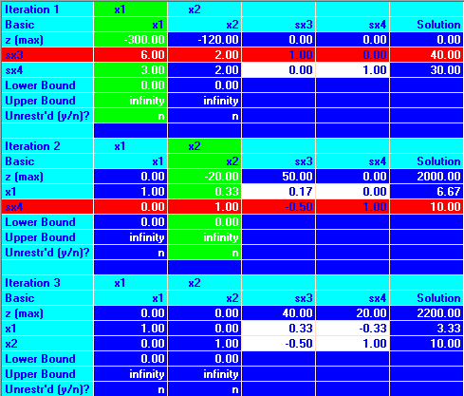

Iteration 2:



Iteration 3 (Optimal):



Now we see that the is non-integer. So we add another constraint known as Gomory’s cut in the original table to solve further.

Gomory’s cut is found to be:

This is added in the original table and solved.

Input in Tora:

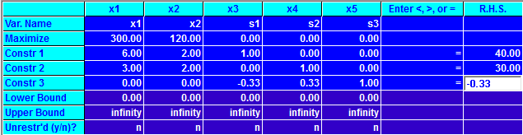

Output:

Iteration 1 and 2:

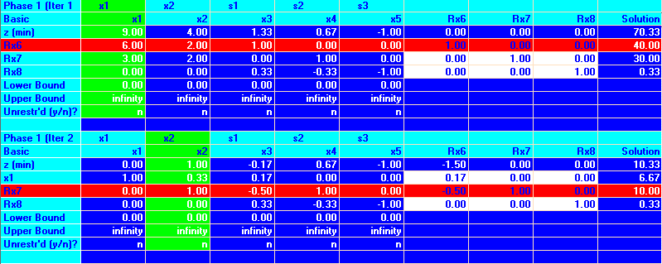

Iteration 3 and 4:

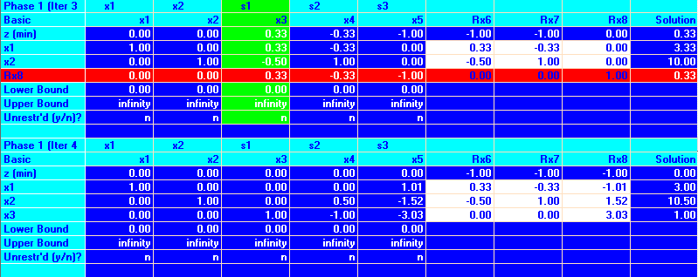

Iteration 5 (Optimal):

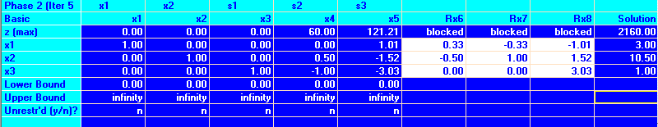

Here we see that is a non-integer therefore we add another Gomory’s cut in the second table to solve it further.

Gomory’s cut for is found to be:

Now we give an input in Tora:

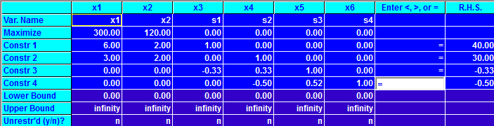

Output:

Iteration 1 and Iteration 2:

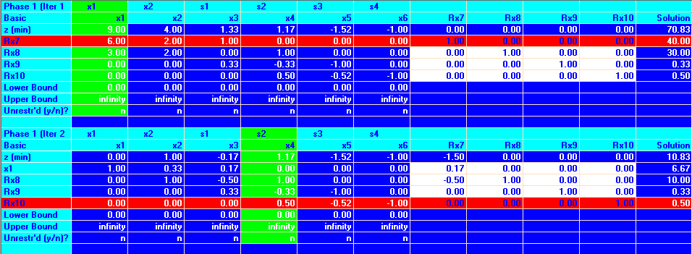

Iteration 3 and Iteration 4:

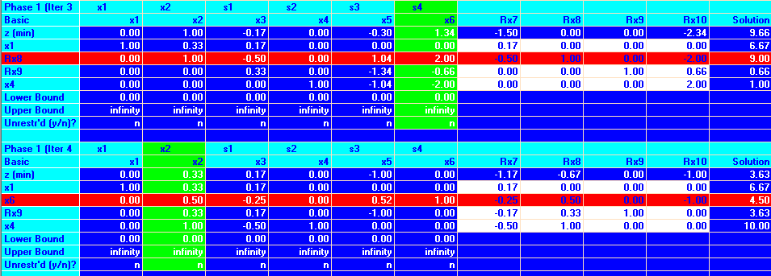

Iteration 5 and Iteration 6:

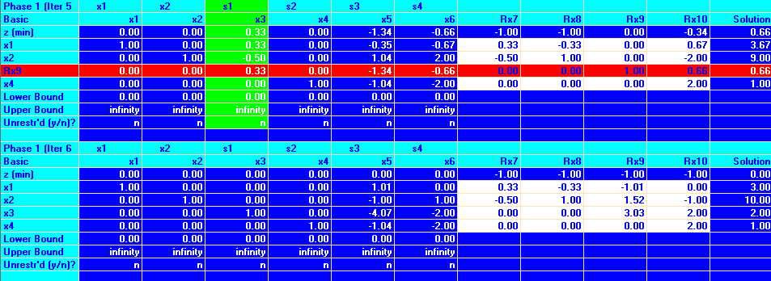

Iteration 7 (Optimal):

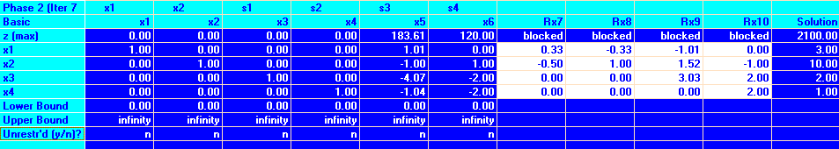

Now we get an optimal solution with both integers.

**Final Solution:** Maximized profit = 2100, if 3 reel-to-reel () and 10 cassette () recorders are made.

**Ques 4.**

ABC manufacturing company faces the following problem: Should they make or buy each of their several products? The company policies specify that they will either make or buy the whole lot of each product in a complete lot. The company has four products to make or buy with six machines involved in making these products if they are made in the shop. The time per unit (in hours) required are as follows:

|  |  |  |  |  |  |  |
| --- | --- | --- | --- | --- | --- | --- |
| Product | Machine | | | | | |
| A | B | C | D | E | F |
| 1 | 0.04 | 0.02 | 0.02 | 0 | 0.03 | 0.06 |
| 2 | 0 | 0.01 | 0.05 | 0.15 | 0.09 | 0.06 |
| 3 | 0.02 | 0.06 | 0 | 0.06 | 0.02 | 0.02 |
| 4 | 0.06 | 0.04 | 0.15 | 0 | 0 | 0.05 |

Forty hours are available of each machine. One hundred ten units of each product are needed. The costs of making the products are listed below:

|  |  |  |  |  |
| --- | --- | --- | --- | --- |
| Products: | 1 | 2 | 3 | 4 |
| Cost/unit (in Rs.): | 2.25 | 2.22 | 4.50 | 1.90 |

The costs to buy the products are:

|  |  |  |  |  |
| --- | --- | --- | --- | --- |
| Products: | 1 | 2 | 3 | 4 |
| Cost/unit (in Rs.): | 3.10 | 2.60 | 4.75 | 2.25 |

Formulate this problem as a zero-one integer programming problem.

**Solution:**

Let x = cost of making product and y = cost of buying product.

So, the formulated problem is:

Subject to:



All

INPUT:

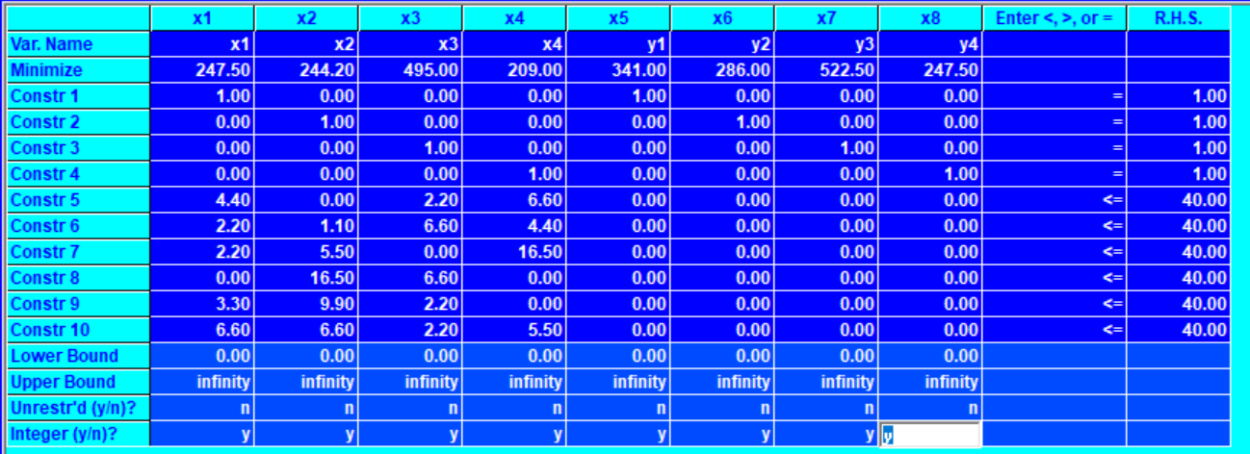

OUTPUT:

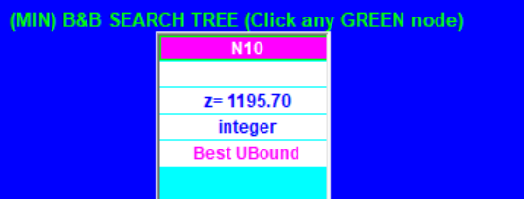

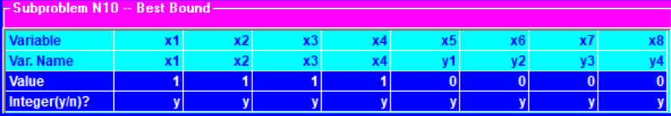

Min Z = 1195.70

With the values

**Ques 5.**

Consider the following production data:

|  |  |  |
| --- | --- | --- |
| **Product** | **Profit Per Unit (Rs.)** | **Direct Labor Requirement (in Hours)** |
| 1 | 8 | 15 |
| 2 | 10 | 14 |
| 3 | 7 | 17 |

|  |  |
| --- | --- |
| **Fixed Cost** | **Direct Labor Requirement** |
| 10,000 | Up to 20,000 hours |
| 20,000 | 20,000-40,000 hours |
| 30,000 | 40,000-70,000 hours |

Formulate an integer programming problem to determine the production schedule so as to maximize the total net profit.

**Solution:**

Let the profit for product 1, 2 and 3 be denoted by respectively.

Let the fixed variables for product 1, 2 and 3 be denoted by respectively.

The formulated problem is:

Input in Tora:

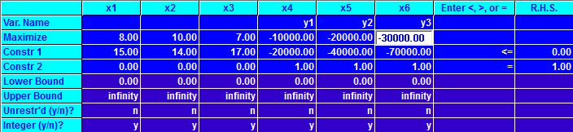

Output:

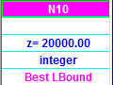

Detailed values:

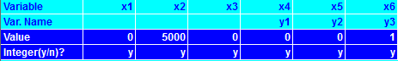

**Final Solution:** Maximized profit = 20000, if 5000 product 2 () units are made.

**Ques 6.**

Solve the following problem for profit maximization:

|  |  |  |  |  |  |  |  |
| --- | --- | --- | --- | --- | --- | --- | --- |
| **Model** | **Quantity** | **Plant A** | **Plant B** | **Plant C** | **Capacity** | **Selling Price** | **Plant** |
| **Standard** | 450 | 8 | 7.95 | 8.10 | 800 | 14.95 | A |
| **Deluxe** | 1050 | 8.50 | 8.60 | 8.45 | 600 | 18.85 | B |
| **New Deluxe** | 600 | 9.25 | 9.20 | 9.30 | 700 | 21.95 | C |

**Solution:**

New profit matrix after subtracting selling price from variable cost:

|  |  |  |  |  |
| --- | --- | --- | --- | --- |
| **Model** | **Plant A** | **Plant B** | **Plant C** | **Quantity** |
| **Standard** | 6.95 | 7 | 6.85 | 450 |
| **Deluxe** | 10.35 | 10.25 | 10.40 | 1050 |
| **New Deluxe** | 12.70 | 12.75 | 12.65 | 600 |
| **Capacity** | 800 | 600 | 700 |  |

Now forming an Integer Programming Problem:

Input in Tora:

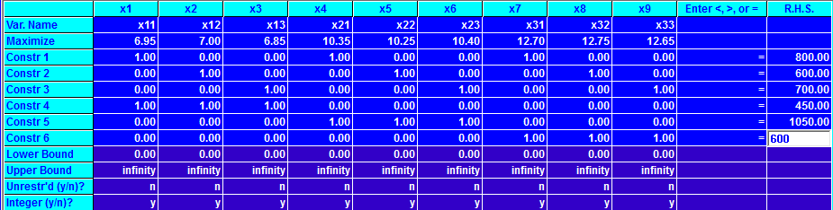

Output:



Detailed output with all the values:

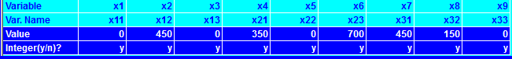

**Final Solution:** Following allocations would make the profit maximized to Rs. 21,680:

|  |  |  |  |  |
| --- | --- | --- | --- | --- |
| **Model** | **Plant A** | **Plant B** | **Plant C** | **Quantity** |
| **Standard** | 0 | 450 | 0 | 450 |
| **Deluxe** | 350 | 0 | 700 | 1050 |
| **New Deluxe** | 450 | 150 | 0 | 600 |
| **Capacity** | 800 | 600 | 700 |  |

**Ques 7.**

Find the minimum cost for covering all zones:

|  |  |  |  |  |  |  |
| --- | --- | --- | --- | --- | --- | --- |
|  | **i** | **ii** | **iii** | **iv** | **v** | **vi** |
| **A** | 73 | 91 | 87 | 82 | 78 | 80 |
| **B** | 81 | 85 | 69 | 76 | 74 | 85 |
| **C** | 75 | 72 | 83 | 84 | 78 | 91 |
| **D** | 93 | 96 | 86 | 91 | 83 | 82 |
| **E** | 90 | 91 | 79 | 89 | 89 | 76 |

**Solution:**

New balanced Matrix:

|  |  |  |  |  |  |  |
| --- | --- | --- | --- | --- | --- | --- |
|  | **i** | **ii** | **iii** | **iv** | **v** | **vi** |
| **A** | 73 | 91 | 87 | 82 | 78 | 80 |
| **B** | 81 | 85 | 69 | 76 | 74 | 85 |
| **C** | 75 | 72 | 83 | 84 | 78 | 91 |
| **D** | 93 | 96 | 86 | 91 | 83 | 82 |
| **E** | 90 | 91 | 79 | 89 | 89 | 76 |
| **F** | 0 | 0 | 0 | 0 | 0 | 0 |

Formulated IPP:

**Input in Tora:**

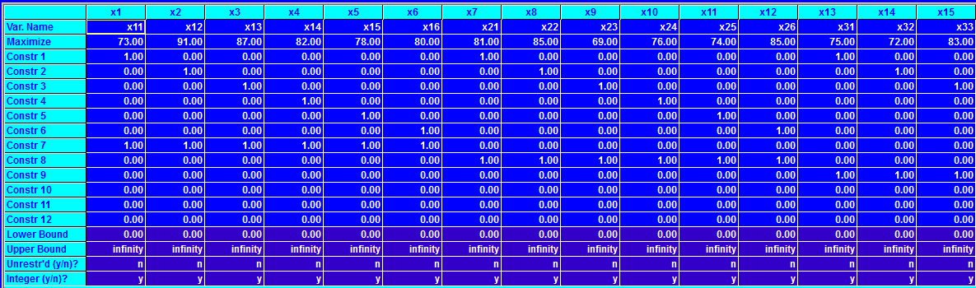

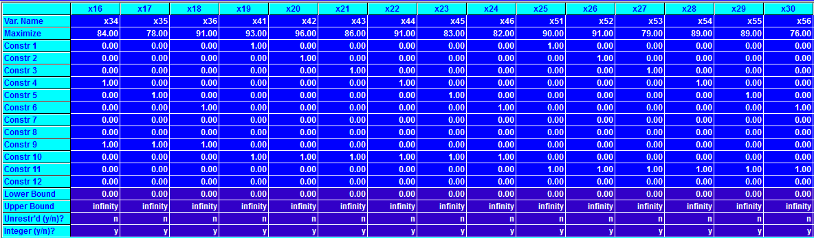

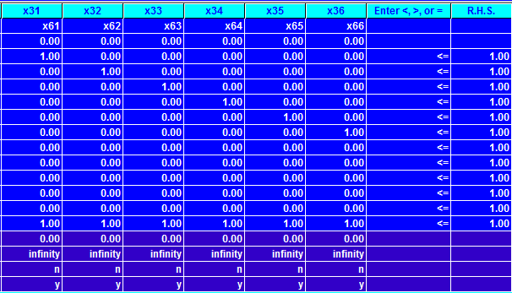

**Output:**

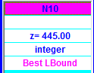

**Detailed output with all the values:**





**Ques 8.** A manufacturer has distribution centers at Agra, Allahabad and Kolkata. These centers have availability of 40, 20 and 40 units of his product respectively. His retail outlets at A , B , C , D , E require 25 , 10, 20 , 30 and 15 units of the products respectively. The transport cost (in rupees) per unit between each center outlet is given below: -

|  |  |  |  |  |  |
| --- | --- | --- | --- | --- | --- |
| **Distribution Centre** | **Retail Outlets** | | | | |
|  | **A** | **B** | **C** | **D** | **E** |
| **Agra** | 55 | 30 | 40 | 50 | 40 |
| **Allahabad** | 35 | 30 | 100 | 45 | 60 |
| **Kolkata** | 40 | 60 | 95 | 35 | 30 |

Determine the optimal distribution so as to minimize the cost of transportation.

**Solution:** Formulated IPP:

**Subject to: -**

**Input in Tora:**

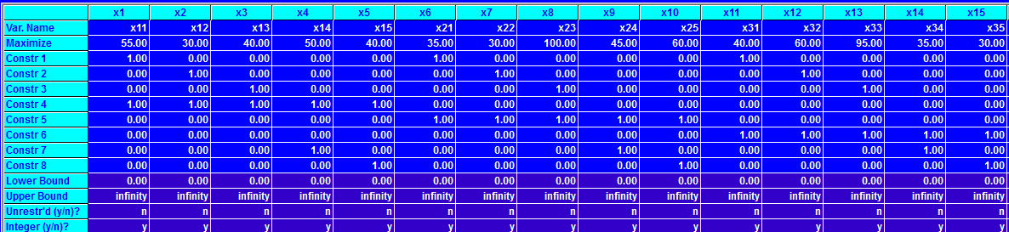

**Output:**

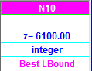

**Detailed Output with all the values:-**



**Ques 9.** Find minimum production cost.

|  |  |  |  |  |  |
| --- | --- | --- | --- | --- | --- |
|  | Jan | Feb | Mar | Apr | May |
| Production cost | 24 | 27 | 32 | 50 | 34 |
| Demand | 200 | 250 | 150 | 80 | 120 |
| Capacity | 250 | 225 | 250 | 200 | 225 |

Inventory carrying cost: 5 per unit per month

**Solution:**

|  |  |  |  |  |  |  |
| --- | --- | --- | --- | --- | --- | --- |
|  | **Jan** | **Feb** | **Mar** | **Apr** | **May** | **Supply** |
| **Jan** | 24 | 29 | 34 | 39 | 44 | 250 |
| **Feb** | - | 27 | 32 | 37 | 42 | 225 |
| **Mar** | - | - | 32 | 37 | 42 | 250 |
| **Apr** | - | - | - | 50 | 55 | 200 |
| **May** | - | - | - | - | 34 | 225 |
| **Demand** | 200 | 250 | 150 | 80 | 120 |  |

**Rim condition not satisfied, adding a dummy variable.**

|  |  |  |  |  |  |  |  |
| --- | --- | --- | --- | --- | --- | --- | --- |
|  | **Jan** | **Feb** | **Mar** | **Apr** | **May** | **Dummy** | **Supply** |
| **Jan** | 24 | 29 | 34 | 39 | 44 | 0 | 250 |
| **Feb** | - | 27 | 32 | 37 | 42 | 0 | 225 |
| **Mar** | - | - | 32 | 37 | 42 | 0 | 250 |
| **Apr** | - | - | - | 50 | 55 | 0 | 200 |
| **May** | - | - | - | - | 34 | 0 | 225 |
| **Demand** | 200 | 250 | 150 | 80 | 120 | 350 |  |

This will generate the following integer programming problem:

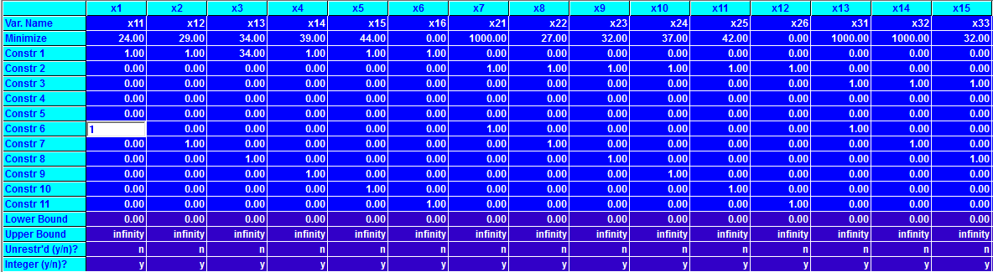

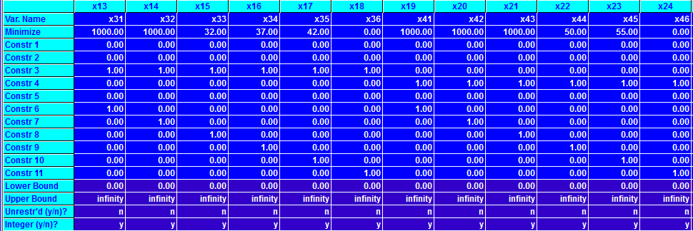

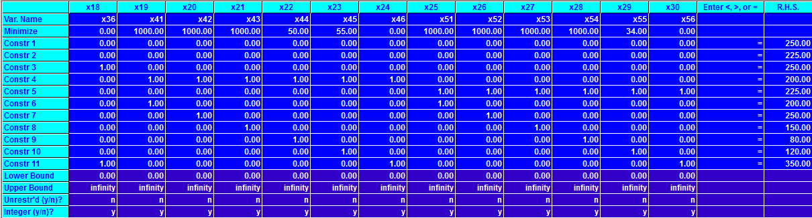

**Output:**

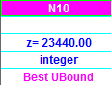

**Detailed output with all the values:**





**Ques 10.** Find minimum production cost.

|  |  |  |  |  |
| --- | --- | --- | --- | --- |
| **Month** | **Max Production** | **Demand** | **Production Cost** | **Inventory Cost** |
| **Jan** | 120 | 100 | 60 | 15 |
| **Feb** | 120 | 130 | 60 | 15 |
| **March** | 150 | 160 | 55 | 20 |
| **April** | 150 | 160 | 55 | 20 |
| **May** | 150 | 140 | 50 | 20 |
| **June** | 150 | 140 | 50 | 20 |

**Solution:**

|  |  |  |  |  |  |  |  |
| --- | --- | --- | --- | --- | --- | --- | --- |
|  | **Jan** | **Feb** | **Mar** | **Apr** | **May** | **June** | **Supply** |
| **Jan** | 60 | 75 | 90 | 110 | 130 | 150 | 120 |
| **Feb** | - | 60 | 75 | 95 | 115 | 135 | 120 |
| **Mar** | - | - | 55 | 75 | 95 | 115 | 150 |
| **Apr** | - | - | - | 55 | 75 | 95 | 150 |
| **May** | - | - | - | - | 50 | 70 | 150 |
| **June** |  |  |  |  |  | 50 | 150 |
| **Demand** | 100 | 130 | 160 | 160 | 140 | 140 |  |

Supply not equal to demand, we add a dummy variable

|  |  |  |  |  |  |  |  |  |
| --- | --- | --- | --- | --- | --- | --- | --- | --- |
|  | **Jan** | **Feb** | **Mar** | **Apr** | **May** | **June** | **Dummy** | **Supply** |
| **Jan** | 60 | 75 | 90 | 110 | 130 | 150 | 0 | 120 |
| **Feb** | - | 60 | 75 | 95 | 115 | 135 | 0 | 120 |
| **Mar** | - | - | 55 | 75 | 95 | 115 | 0 | 150 |
| **Apr** | - | - | - | 55 | 75 | 95 | 0 | 150 |
| **May** | - | - | - | - | 50 | 70 | 0 | 150 |
| **June** |  |  |  |  |  | 50 | 0 | 150 |
| **Demand** | 100 | 130 | 160 | 160 | 140 | 140 | 10 |  |

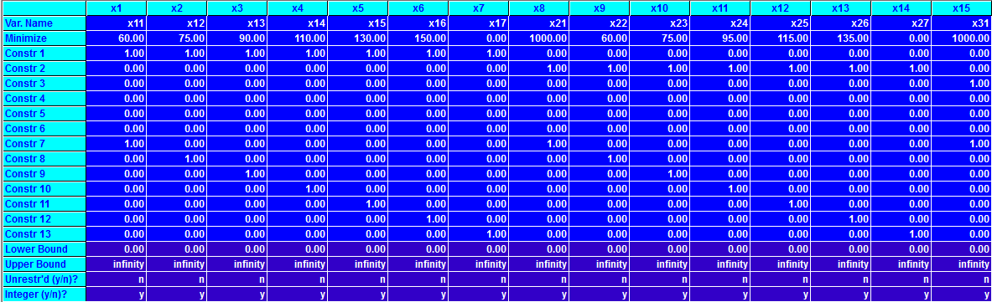

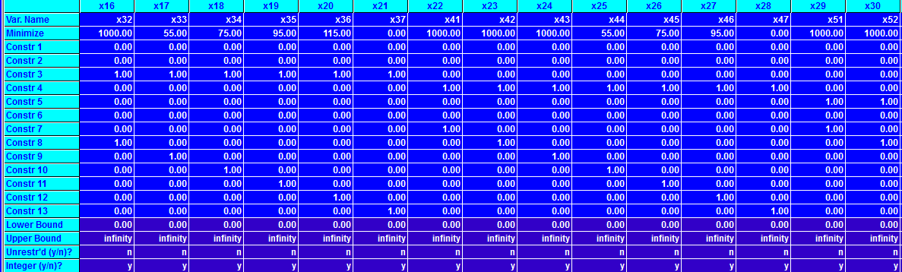

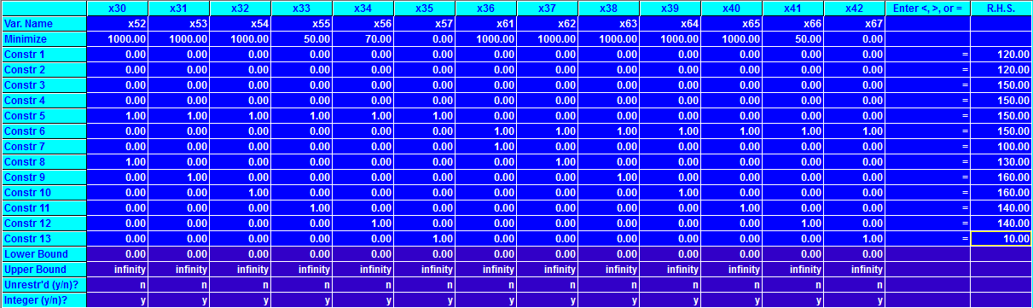

Output:

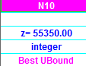

Detailed output:







**Ques 11.**

ABC Company wishes to develop a monthly production schedule for the next three months depending upon the sales commitments, the company can keep the production constant, allowing fluctuations in inventory or inventories can be maintained at constant level, with fluctuating production. Fluctuating production necessitates, working overtime, the cost of which is estimated to be double the normal production cost of 12 Rupee per unit. Fluctuating inventories result in inventory carrying of 2 Rupee per unit per month. If the company fails to fulfill its sales commitment it incurs a shortage cost of 4 Rupee per unit per month. The production capacities for the next three month are shown in table: -

**Production Capacity**

|  |  |  |  |
| --- | --- | --- | --- |
| Month | Regular | Overtime | Sales |
| 1 | 50 | 30 | 60 |
| 2 | 50 | 0 | 120 |
| 3 | 60 | 50 | 40 |

Determine optimal production schedule.

Solution:

|  |  |  |  |  |  |
| --- | --- | --- | --- | --- | --- |
|  | 1 | 2 | D | 3 |  |
| R1 | 12 | 14 | 0 | 16 | 50 |
| O1 | 24 | 26 | 0 | 28 | 30 |
| R2 | 16 | 12 | 0 | 14 | 50 |
| R3 | 20 | 16 | 0 | 12 | 60 |
| O3 | 32 | 28 | 0 | 24 | 50 |
|  | 60 | 120 | 20 | 40 | 240 |

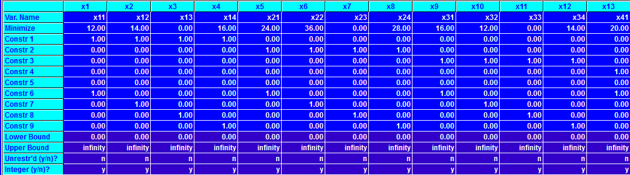

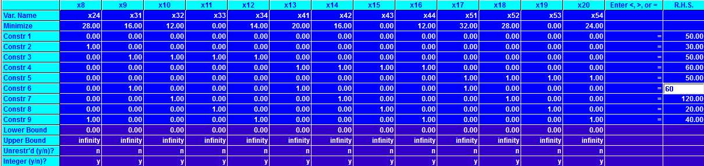

Output:

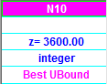

Detailed output:





**Ques 12.**

Consider the game with the following payoff table:

|  |  |  |
| --- | --- | --- |
|  | Player B | |
| Player A | B1 | B2 |
| A1 | 2 | 6 |
| A2 | -2 |  |

1. Show that the game is strictly determinable, whatever may be.
2. Determine the value of the game.

**Solution:**

Solving the above game using excel:

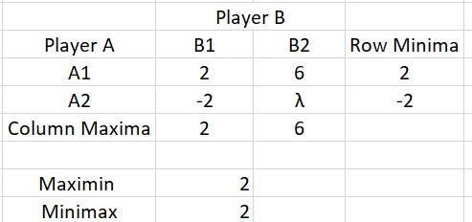

1. Ignoring the value of λ, the maximin = minimax = 2.

Thus, the game is strictly determinable.

1. The value of game,

V = 2

**Ques 13.**

Determine which of the following two-person zero sum games are strictly determinable and fair. Give the optimum strategies for each player in the case of strictly determinable

a)

|  |  |  |
| --- | --- | --- |
|  | Player B | |
| Player A | B1 | B2 |
| A1 | 1 | 2 |
| A2 | 4 | -3 |

b)

|  |  |  |
| --- | --- | --- |
|  | Player B | |
| Player A | B1 | B2 |
| A1 | -5 | 2 |
| A2 | -7 | -4 |

**Solution:**

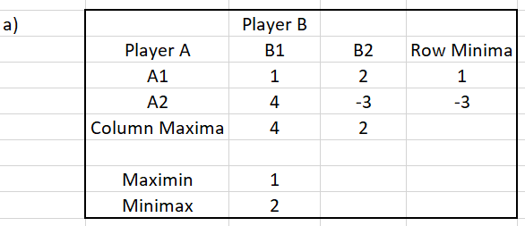

Since, Maximin != Minimax

Therefore, game (a) does not have a saddle point. So, game a is neither strictly determinable nor fair.

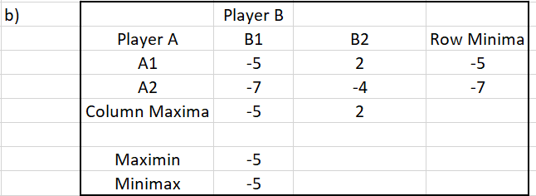

Here, Minimax = Maximin. So, the value of the game is -5.

This game is strictly determinable but not fair.

Player A chooses strategy A1, and Player B chooses strategy B1.

**Ques 14.**

Solve the following game by using maximin(minimax) principle whose payoff matrix are given below: Include in your answer:

1. Strategy selection for each player
2. The value of the game to each player

Does the game have saddle point?

|  |  |  |  |  |
| --- | --- | --- | --- | --- |
|  | Player B | | | |
| Player A | B1 | B2 | B3 | B4 |
| A1 | 1 | 7 | 3 | 4 |
| A2 | 5 | 6 | 4 | 5 |
| A3 | 7 | 2 | 0 | 3 |

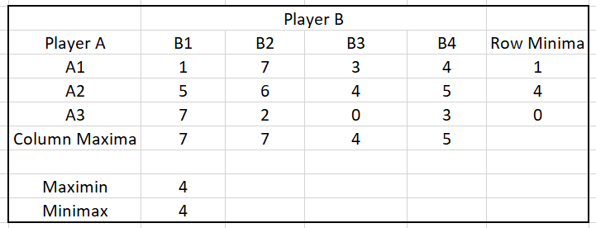

Here, Minimax = Maximin. Therefore, it has a saddle point and the value of the game is 4.

This game is strictly determinable.

Player A chooses strategy A2, and Player B chooses strategy B3.

**Ques 15.**

Solve the following game by using maximin(minimax) principle whose payoff matrix are given below: Include in your answer:

1. Strategy selection for each player
2. The value of the game to each player

|  |  |  |  |  |  |
| --- | --- | --- | --- | --- | --- |
|  | Player B | | | | |
| Player A | B1 | B2 | B3 | B4 | B5 |
| A1 | -2 | 0 | 0 | 5 | 3 |
| A2 | 3 | 2 | 1 | 2 | 2 |
| A3 | -4 | -3 | 0 | -2 | 6 |
| A4 | 5 | 3 | -4 | 2 | 6 |

**Solution:**

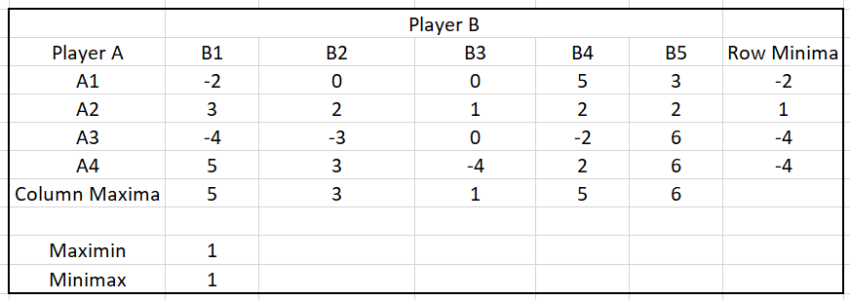

Here, Minimax = Maximin. Therefore, it has a saddle point and the value of the game is 4.

This game is strictly determinable.

Player A chooses strategy A2, and Player B chooses strategy B3.

**Ques 16.**

Solve the following game by using maximin(minimax) principle whose payoff matrix are given below: Include in your answer:

1. Strategy selection for each player
2. The value of the game to each player

Does the game have saddle point?

|  |  |  |  |  |
| --- | --- | --- | --- | --- |
|  | Player B | | | |
| Player A | B1 | B2 | B3 | B4 |
| A1 | 3 | -5 | 0 | 6 |
| A2 | -4 | -2 | 1 | 2 |
| A3 | 5 | 4 | 2 | 3 |

**Solution:**

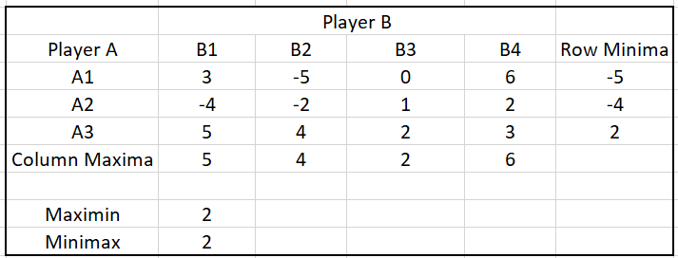

Here, Minimax = Maximin. Therefore, it has a saddle point and the value of the game is 2.This game is strictly determinable.

Player A chooses strategy A3, and Player B chooses strategy B3.

**Ques 17.**

Solve the following game by using maximin(minimax) principle whose payoff matrix are given below: Include in your answer:

1. Strategy selection for each player
2. The value of the game to each player

|  |  |  |  |
| --- | --- | --- | --- |
|  | Player B | | |
| Player A | B1 | B2 | B3 |
| A1 | -2 | 15 | -2 |
| A2 | -5 | -6 | -4 |
| A3 | -5 | 20 | -8 |

**Solution:**

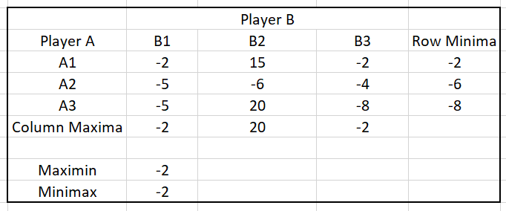

Here, Minimax = Maximin. Therefore, it has a saddle point and the value of the game is -2.

This game is strictly determinable.

There are two points of optimal strategies (A1, B1) & (A1, B3).

**Ques 18.**

Solve the following game by using maximin(minimax) principle whose payoff matrix are given below: Include in your answer:

1. Strategy selection for each player
2. The value of the game to each player

Does the game have saddle point?

|  |  |  |  |  |
| --- | --- | --- | --- | --- |
|  | Player B | | | |
| Player A | B1 | B2 | B3 | B4 |
| A1 | -5 | 3 | 1 | 10 |
| A2 | 5 | 5 | 4 | 6 |
| A3 | 4 | -2 | 0 | -5 |

**Solution:**

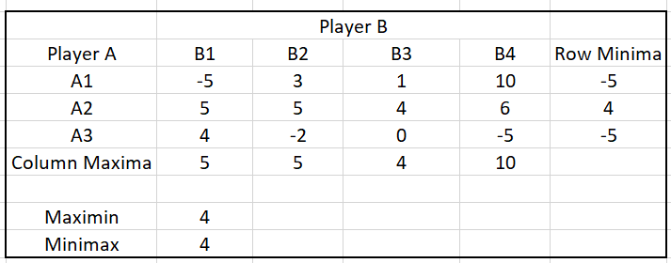

Here, Minimax = Maximin. Therefore, it has a saddle point and the value of the game is 4.

This game is strictly determinable.

Player A chooses strategy A2, and Player B chooses strategy B3.

**Ques 19.**

Two competitive manufacturers are producing a new toy under license from a patent holder. In order to meet the demand, they have the option of running the plant for 8, 16 or 24 hours a day. As the length of production increases so does the cost. One of the manufacturers, say A, has set up the matrix given below. He uses the matrix to estimate the percentage of the market that he could capture and maintain the different production schedules:

|  |  |  |  |
| --- | --- | --- | --- |
|  | Manufacturer B | | |
| Manufacturer A | C1: 8 hrs. | C2:16 hrs. | C3:24 hrs. |
| S1:8 hrs. | 60% | 56% | 34% |
| S2:16 hrs. | 63% | 60% | 55% |
| S3:24 hrs. | 83% | 72% | 60% |

**Solution:**

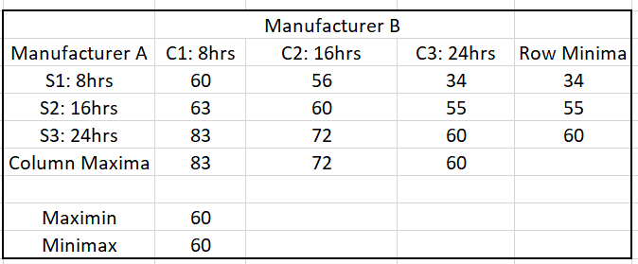

Here, Minimax = Maximin. Therefore, it has a saddle point and the value of the game is 60.

This game is strictly determinable.

Optimal Strategy: (S3, C3), i.e. both should produce at the level of 24hours per day.

**Ques 20.**

Solve graphically, the rectangular game, whose payoff matrix is:

|  |  |  |  |  |
| --- | --- | --- | --- | --- |
|  | Player B | | | |
| Player A | B1 | B2 | B3 | B4 |
| A1 | 2 | 1 | 0 | -2 |
| A2 | 1 | 0 | 3 | 2 |

**Solution:**

Since, it is a 2×n game therefore, we can solve the given rectangular game using graphical method.

Solving the given game in TORA using graphical method:

INPUT:

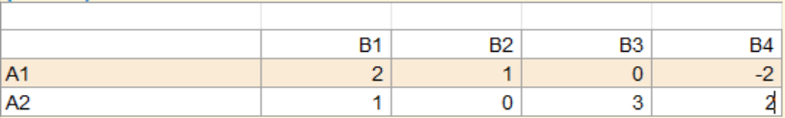

OUTPUT:

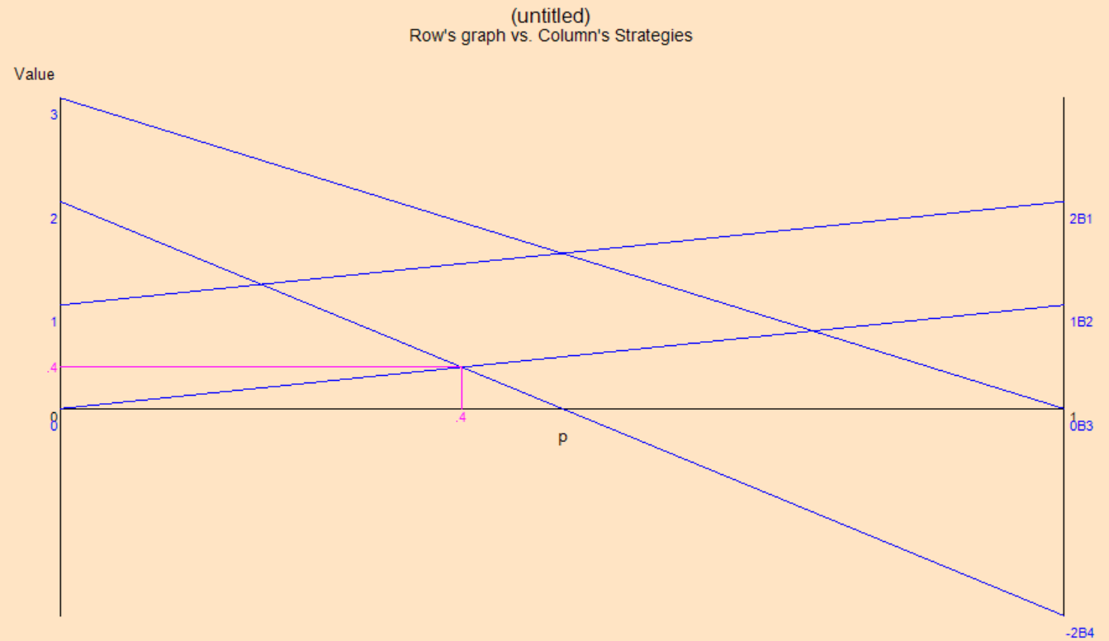

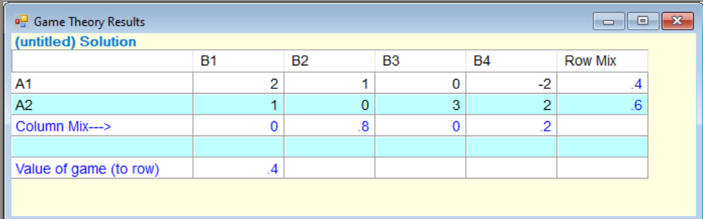

Here, the optimal strategy of player A and B are respectively:

||0.4, 0.6|| and ||0, 0.8, 0, 0.2||

And, the value of game is 0.4.

**Ques 21.**

Solve graphically, the rectangular game, whose payoff matrix is:

|  |  |  |
| --- | --- | --- |
|  | Player B | |
| Player A | B1 | B2 |
| A1 | 1 | -3 |
| A2 | 3 | 5 |
| A3 | -1 | 6 |
| A4 | 4 | 1 |
| A5 | 2 | 2 |
| A6 | -5 | 0 |

**Solution:**

Since, it is a m×2 game therefore, we can solve the given rectangular game using graphical method.

Solving the given game in POM QM using graphical method:

INPUT:

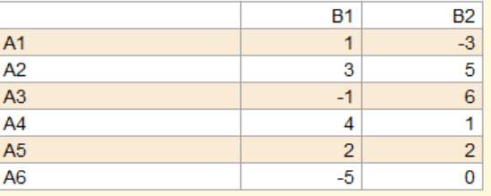

OUTPUT:

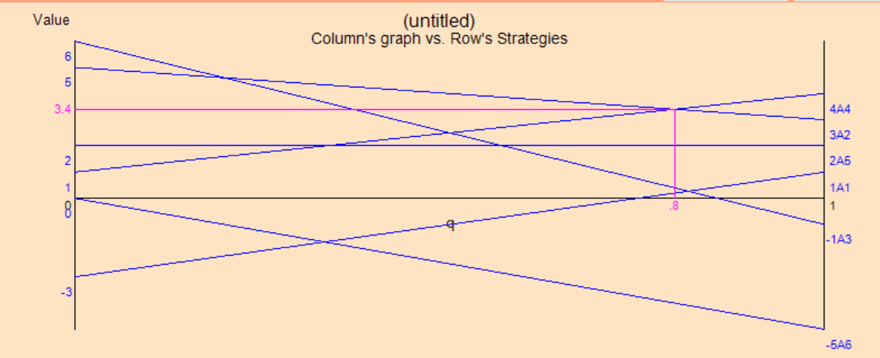

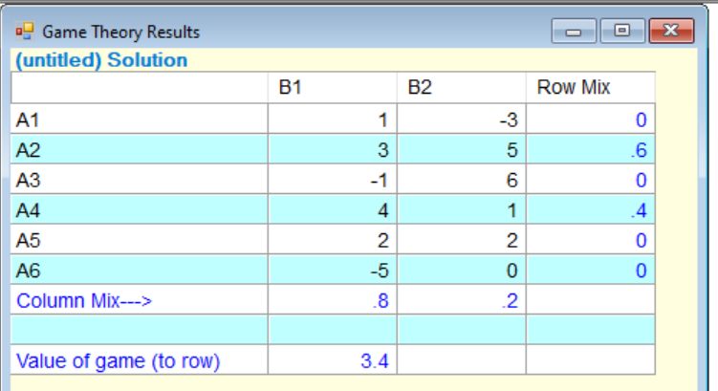

Here, the optimal strategy of player A and B are respectively:

||0, 0.6, 0, 0.4, 0, 0|| and ||0.8, 0.2||

And, the value of game is 3.4.

**Ques 22.**

Solve graphically, the rectangular game, whose payoff matrix is:

|  |  |  |  |  |
| --- | --- | --- | --- | --- |
|  | Player B | | | |
| Player A | B1 | B2 | B3 | B4 |
| A1 | 6 | 5 | 2 | 3 |
| A2 | 1 | 2 | 6 | 3 |

**Solution:**

Since, it is a 2×n game therefore, we can solve the given rectangular game using graphical method.

Solving the given game in POM QM using graphical method:

INPUT:

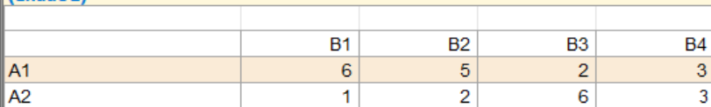

OUTPUT:

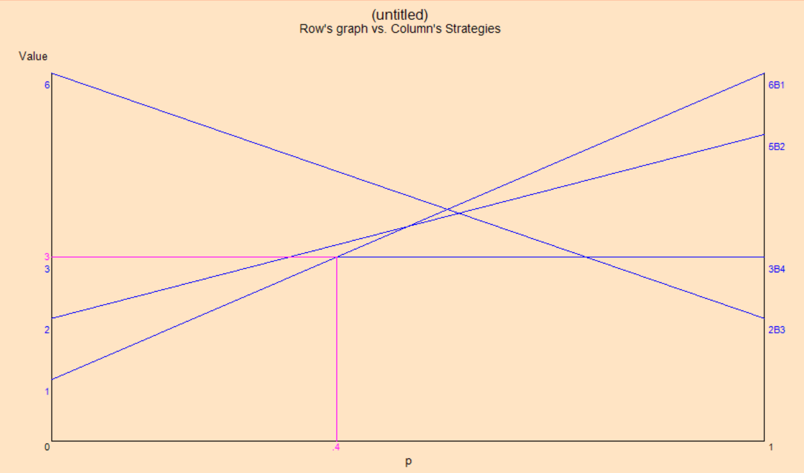

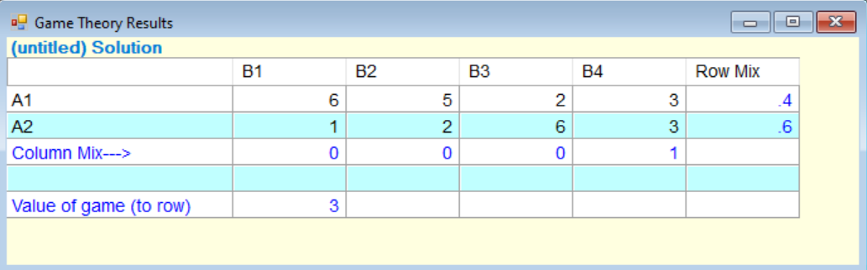

Here, the optimal strategy of player A and B are respectively:

||0.4, 0.6|| and ||0, 0, 0, 1||

And, the value of game is 3.

**Ques 23.**

Solve graphically, the rectangular game, whose payoff matrix is:

|  |  |  |  |  |
| --- | --- | --- | --- | --- |
|  | Player B | | | |
| Player A | B1 | B2 | B3 | B4 |
| A1 | 3 | 1 | 0 | -2 |
| A2 | 1 | 0 | 3 | 2 |

**Solution:**

Since, it is a 2×n game therefore, we can solve the given rectangular game using graphical method.

Solving the given game in POM QM using graphical method:

INPUT:

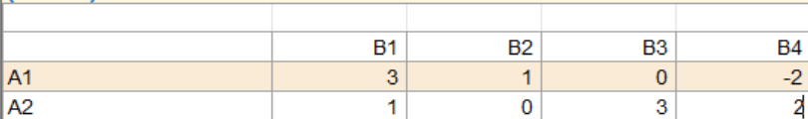

OUTPUT:

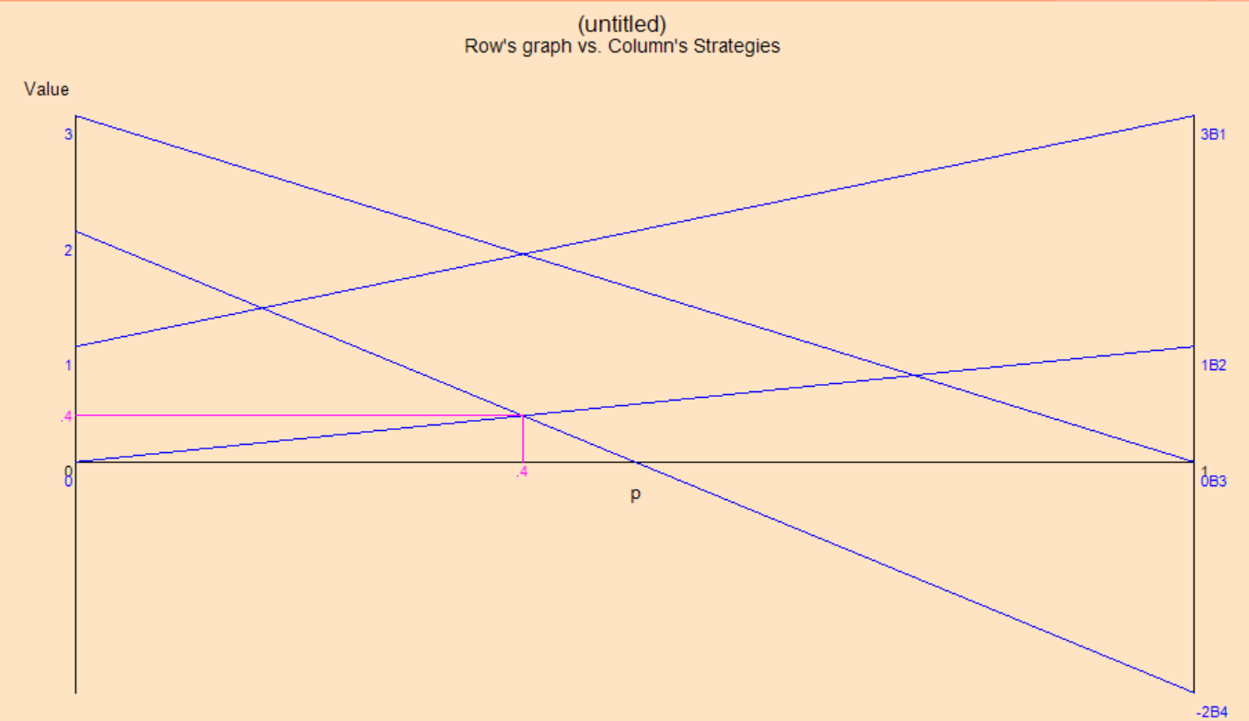

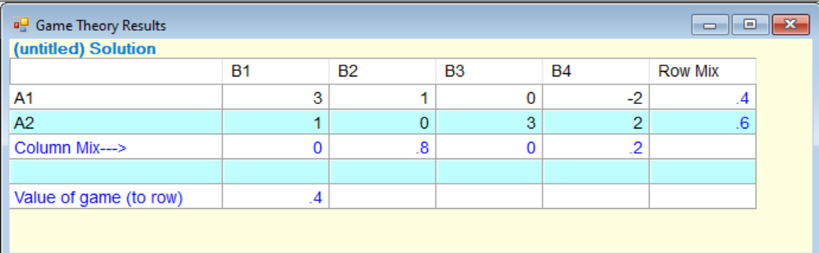

Here, the optimal strategy of player A and B are respectively:

||0.4, 0.6|| and ||0, 0.8, 0, 0.2||

And, the value of game is 0.4.

**Ques 24.**

Two computer manufacturers A and B are attempting to sell computer systems to two banks 1 and 2. Company A has 4 salesmen; company B only has 3 salesmen available. The computer companies must decide upon how many salesmen to assign to sell computer to each bank. Thus, company A can assign 4 salesmen to bank 1 and none to bank 2 or three to bank 1 and one to bank 2, etc.

Each bank will buy one computer system. The probability that a bank will buy from a particular computer company is directly related to the number of salesmen calling from that company, relative to the total salesmen calling. Thus, if company A assigns three salesmen to bank 1 and company B assigns two salesmen, the odds would be three out of five that bank 1 would purchase company A’s computer system. (If none calls from either company the odds are one-half for buying either computer.)

Let the payoff be the expected number of computer systems that company A sells. (2 minus this payoff is the expected number company B sells).

What strategy would company A use in allocating its salesmen? What strategy should company B use? What is the value of the game to company A? What is the meaning of the value of the game in this problem?

**Solution:**

Payoff Matrix:

|  |  |  |  |  |  |
| --- | --- | --- | --- | --- | --- |
| Player A |  | B1 | B2 | B3 | B4 |
|  |  | 0 | 1 | 2 | 3 |
| A1 | 0 | 1/2 | 0 | 0 | 0 |
| A2 | 1 | 1 | 1/2 | 1/3 | 1/4 |
| A3 | 2 | 1 | 2/3 | 1/2 | 2/5 |
| A4 | 3 | 1 | 3/4 | 3/5 | 1/2 |
| A5 | 4 | 1 | 4/5 | 2/3 | 4/7 |

Formula used to calculate payoff probabilities:

Final solution:

|  |  |  |  |  |  |  |  |
| --- | --- | --- | --- | --- | --- | --- | --- |
| Player A |  | B1 | B2 | B3 | B4 | B5 | Min |
|  |  | 0 | 1 | 2 | 3 |  |  |
| A1 | 0 | 1/2 | 0 | 0 | 0 |  | 0 |
| A2 | 1 | 1 | 1/2 | 1/3 | 1/4 |  | 1/4 |
| A3 | 2 | 1 | 2/3 | 1/2 | 2/5 |  | 2/5 |
| A4 | 3 | 1 | 3/4 | 3/5 | 1/2 |  | 1/2 |
| A5 | 4 | 1 | 4/5 | 2/3 | 4/7 |  | 4/7 |
|  |  |  |  |  |  |  |  |
| Max |  | 1 | 4/5 | 2/3 | 4/7 |  |  |
|  |  |  |  |  |  |  |  |

|  |  |  |
| --- | --- | --- |
| Minimax |  | 4/7 |
| Maximin |  | 4/7 |

This is a pure strategy, with saddle point at 4/7.

Strategy used by A-> A5

Strategy used by B-> B4

**Ques 25.**

The firms A and B have for years been selling’s a competitive product which forms a part of both firms’ total sales. The marketing executive of firm A raised the question, “What should be the firm’s strategies in terms of advertising product in question?” The market research team of firm A developed the following data for varying degrees of advertising:

1. No advertising, medium advertising, and large advertising for both firms will result in equal market shares.
2. Firm A with no advertising: 40% of market with medium advertising by firm B and 28% of the market with large advertising by firm B
3. Firm A using medium advertising: 70% of the market with no advertising by firm B and 45% of the market with large advertising by firm B
4. Firm A using large advertising: 75% of the market with no advertising by firm B and 47.5% of the market with medium advertising by firm B
5. Based upon their foregoing information, answer the marketing executive’s questions.
6. What advertising policy should firm A pursue when consideration is given to the above factors: selling price Rs. 4 per unit: variable cost of product Rs. 2.5 per unit; annual volume of 30,000 units for firm A; cost of annual medium advertising Rs. 5,000 and cost of annual large advertising Rs. 15,000? What contribution before other fixed costs is available to the firm?

**Solution:**

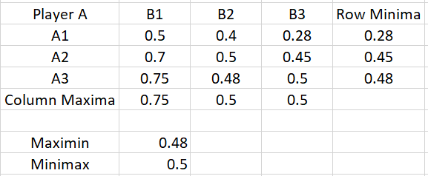

Since, Maximin != Minimax.

Therefore, it is an impure strategy.

Using rule of dominance our new pay off matrix will be:

|  |  |  |
| --- | --- | --- |
|  | B1 | B2 |
| A1 | 0.5 | 0.45 |
| A2 | 0.48 | 0.50 |

Now as we know,

Probability of firm A = p1+p2 = 1

where,

P1 is when strategy A1 is chooses by firm A.

P2 is when strategy A2 is chooses by firm A.

Probability of firm B = q1+q2 = 1

where, q1 is when strategy B1 is chosen by firm B.

and, q2 is when strategy B2 is chosen by firm B.

Now,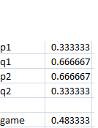

**Quantity table:**

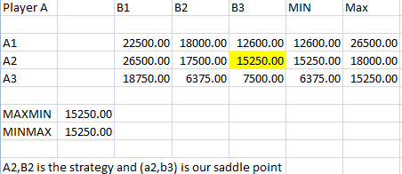

**Profit table:**



Firm A should adopt medium strategy and spend Rs 5000.

**Ques 26.**

Solve the given payoff matrix. Transfer the zero sum two-person game into equivalent linear programming problem. Solve using Simplex Method.

|  |  |  |  |
| --- | --- | --- | --- |
|  | **B1** | **B2** | **B3** |
| **A1** | **5** | **3** | **7** |
| **A2** | **7** | **9** | **1** |
| **A3** | **10** | **6** | **2** |

**Solution:**

The given payoff matrix will result in following LPP:

INPUT IN TORA:

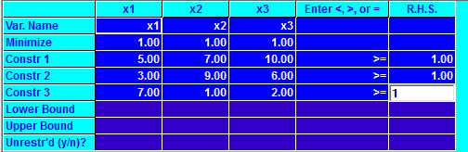

OUTPUT:

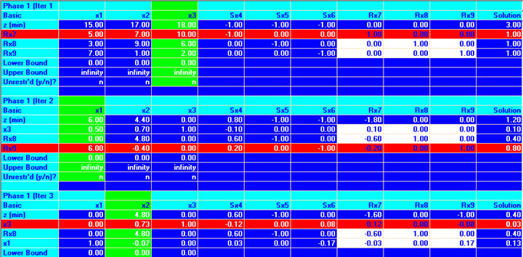

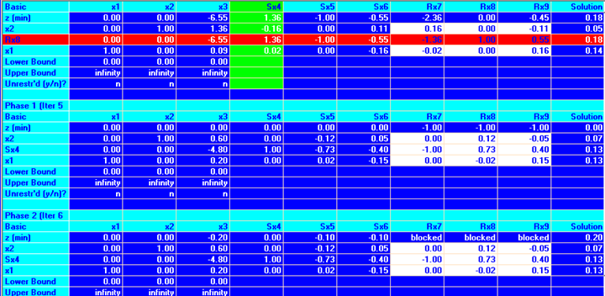

Value of Z = 0.20 therefore V = 5, since Z = 1/v

**Ques 27.**

For the following payoff matrix, transform the zero sum two-person game into an equivalent linear programming problem and solve it by simplex method.

|  |  |  |  |
| --- | --- | --- | --- |
|  | Player B | | |
| Player A | B1 | B2 | B3 |
| A1 | 9 | 1 | 4 |
| A2 | 0 | 6 | 3 |
| A3 | 5 | 2 | 8 |

**Solution:**

We first add a suitable number so that the value of the game is strictly positive. Adding 1 to all the entries the problem becomes:

|  |  |  |  |
| --- | --- | --- | --- |
|  | Player B | | |
| Player A | B1 | B2 | B3 |
| A1 | 10 | 2 | 5 |
| A2 | 1 | 7 | 4 |
| A3 | 6 | 3 | 9 |

The above payoff matrix will result in the following LPP:

The game for player A is to maximize v,

Subject to

The game for player B is to minimize v,

Subject to

Now, dividing each of the constraints of player A and B by and writing and the constraint can be written as:

and,

A wishes to maximize that is he wishes to

Minimize

Subject to

B wishes to minimize that is he wishes to

Maximize

Subject to

We can see that the previous two LPP’s are primal dual pair. So, if we solve any one, the solution to the other may be obtained from the optimal table of the considered problem. So, we’ll solve the last problem by simplex method using TORA:

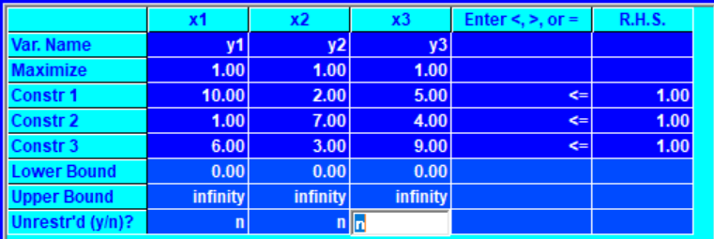

Iteration1 and Iteration2:

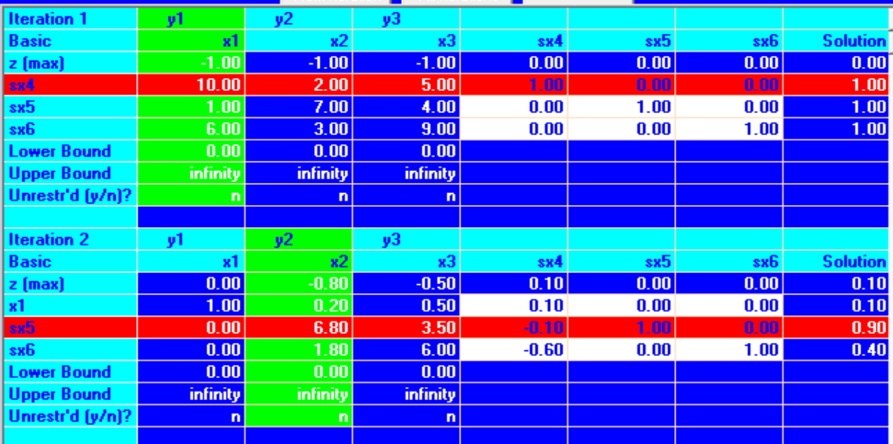

Iteration3:

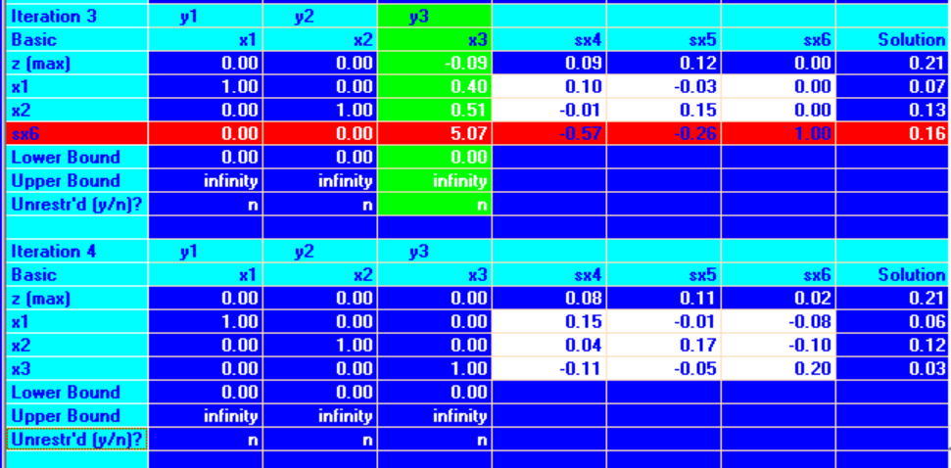

Iteration 4(Optimal):



Value of Z = 0.21 therefore, V = 4.76, since Z = 1/v

Since, we have added 1 to all the entries therefore, value of game,

Therefore, optimal strategy of the two players A and B are respectively;

And the value of game

**Ques 28.**

For the following payoff matrix, transform the zero sum two-person game into an equivalent linear programming problem and solve it by simplex method.

|  |  |  |  |
| --- | --- | --- | --- |
|  | Company A | | |
| Company B | A1 | A2 | A3 |
| B1 | 2 | -2 | 3 |
| B2 | -3 | 5 | -1 |

**Solution:**

Assuming that Company A is gainer so, the new matrix will be:

|  |  |  |
| --- | --- | --- |
|  | Company B | |
| Company A | B1 | B2 |
| A1 | -2 | 3 |
| A2 | 2 | -5 |
| A3 | -3 | 1 |

We first add a suitable number so that the value of the game is strictly positive. Adding 6 to all the entries the problem becomes:

|  |  |  |
| --- | --- | --- |
|  | Company B | |
| Company A | B1 | B2 |
| A1 | 4 | 9 |
| A2 | 8 | 1 |
| A3 | 3 | 7 |

The above payoff matrix will result in the following LPP:

The game for Company A is to maximize v,

Subject to

The game for Company B is to minimize v,

Subject to

Now, dividing each of the constraints of Company A and B by and writing and the constraint can be written as:

and,

A wishes to maximize that is he wishes to

Minimize

Subject to

B wishes to minimize that is he wishes to

Maximize

Subject to

We can see that the previous two LPP’s are primal dual pair. So, if we solve any one, the solution to the other may be obtained from the optimal table of the considered problem. So, we’ll solve the last problem by simplex method using TORA:

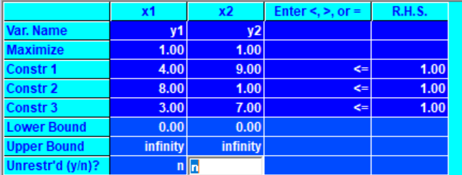

Iteration1:

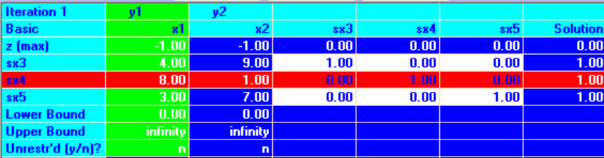

Iteration2:

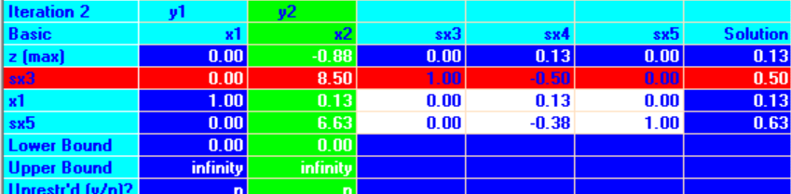

Iteration 3(Optimal):

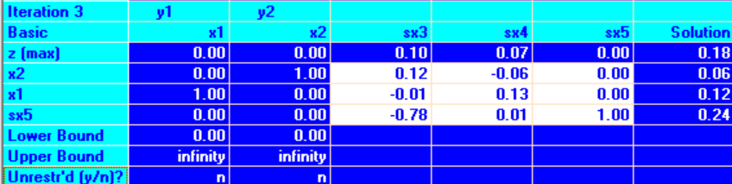

Value of Z = 0.18 therefore, V = 5.55, since Z = 1/v

Since, we have added 6 to all the entries therefore, value of game,

Therefore, optimal strategy of the two Company A and B are respectively;

And the value of game

**Ques 29.**

A soft drink company calculated the market share of two of its products against its major competitor, which has three products. The company found out the impact of additional advertisement in any one of its products against the other.

|  |  |  |  |
| --- | --- | --- | --- |
|  | Company B | | |
| Company A | B1 | B2 | B3 |
| A1 | 6 | 7 | 15 |
| A2 | 20 | 12 | 10 |

What is the best strategy for the company as well as the competitor? What is the payoff obtained by the company and the competitor in the long run? Use the graphical method to obtain the solution.

**Solution:**

Since, it is a 2×n game therefore, we can solve the given rectangular game using graphical method.

Solving the given game in POM QM using graphical method:

INPUT:

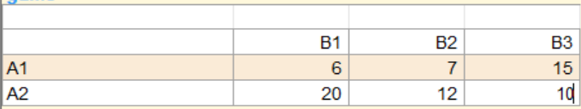

OUTPUT:

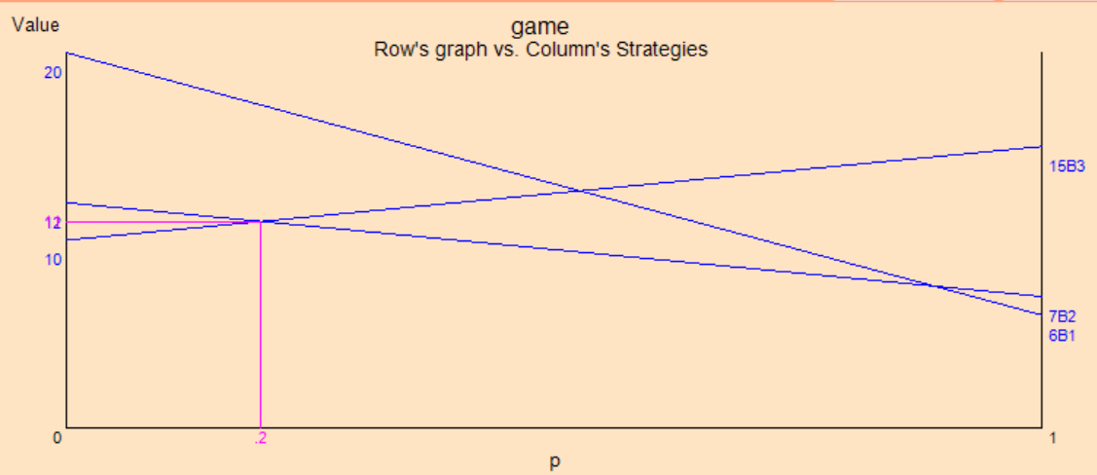

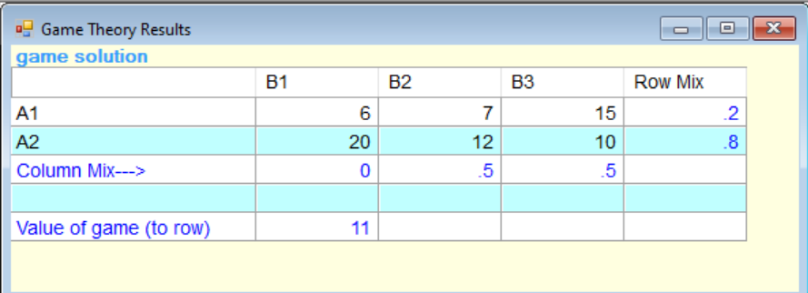

Here, the optimal strategy of player A and B are respectively:

||0.2, 0.8|| and ||0, 0.5, 0, 0.5||

And, the value of game is 11.

**Ques 30.**

Two Firms A and B make color and black & white television sets. Firm A can make either 150 color sets in a week or an equal number of black and white sets, and make a profit of Rs 400 per color set and Rs 300 per black & white set. Firm B can, on the other hand, make either 300 color sets, or 150 color and 150 black & white sets, or 300 black & white sets per week. It also has the same profit margin on the two sets as A. Each week there is a market of 150 color sets and 300 black & white sets. The manufacturers would share market depending upon the proportion in which they manufacture a particular type of set.

Write the payoff matrix of A per week. Obtain, graphically, A’s and B’s optimal strategies and the value of the game.

**Solution:**

Let,

A1: 150 colour sets;

A2: 150 black & white sets

B1: 300 colour sets;

B2: 150 colour and 150 black & white sets;

B3: 300 black & white sets.

The payoff matrix of A per week will be:

|  |  |  |  |
| --- | --- | --- | --- |
|  | Firm B | | |
| Firm A | B1 | B2 | B3 |
| A1 | 20,000 | 30,000 | 60,000 |
| A2 | 45,000 | 45,000 | 30,000 |

Since, it is a 2×n game therefore, we can solve the given rectangular game using graphical method.

Solving the given game in POM QM using graphical method:

INPUT:

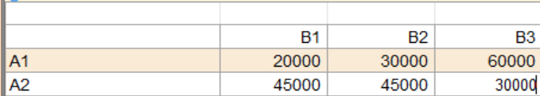

OUTPUT:

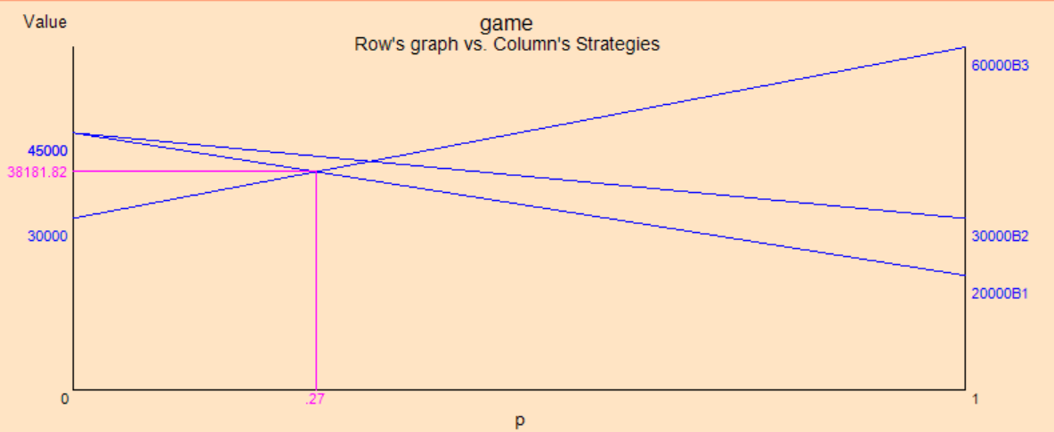

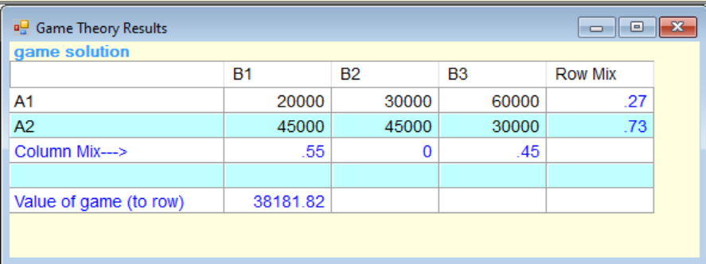

Here, the optimal strategy of player A and B are respectively:

||0.27, 0.73|| and ||0.55, 0, 0.45||

And, the value of game is 38181.82.

**Ques 31.**

In a town there are only two discount stores ABC and XYZ. Both stores run annual pre-Diwali sales. Sales are advertised through local newspapers with the aid of an advertising firm. ABC stores constructed following payoff in units of Rs 1,00,000. Find the optimal strategies for both stores and the value of the game:

|  |  |  |  |
| --- | --- | --- | --- |
|  | Store XYZ | | |
| Store ABC | B1 | B2 | B3 |
| A1 | 1 | -2 | 1 |
| A2 | -1 | 3 | 2 |
| A3 | -1 | -2 | 3 |

**Solution:**

We first add a suitable number so that the value of the game is strictly positive. Adding 3 to all the entries the problem becomes:

|  |  |  |  |
| --- | --- | --- | --- |
|  | Store XYZ | | |
| Store ABC | B1 | B2 | B3 |
| A1 | 4 | 1 | 4 |
| A2 | 2 | 6 | 5 |
| A3 | 2 | 1 | 6 |

The above payoff matrix will result in the following LPP:

The game for player A is to maximize v,

Subject to

The game for player B is to minimize v,

Subject to

Now, dividing each of the constraints of player A and B by and writing and the constraint can be written as:

and,

A wishes to maximize that is he wishes to

Minimize

Subject to

B wishes to minimize that is he wishes to

Maximize

Subject to

We can see that the previous two LPP’s are primal dual pair. So, if we solve any one, the solution to the other may be obtained from the optimal table of the considered problem. So, we’ll solve the last problem by simplex method using TORA:

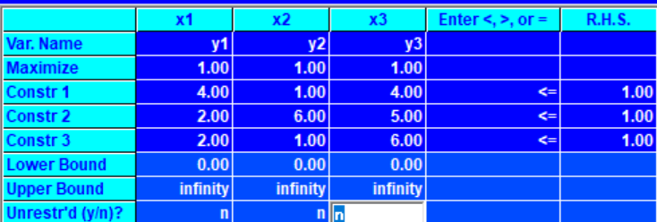

Iteration1 and Iteration2:

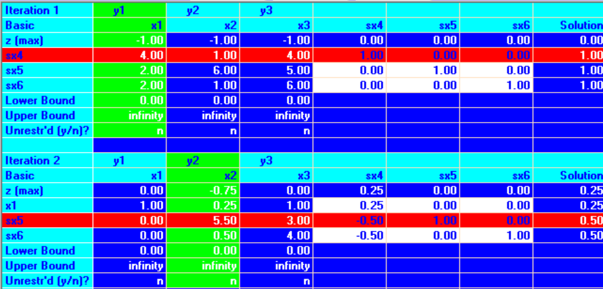

Iteration3 (Optimal):

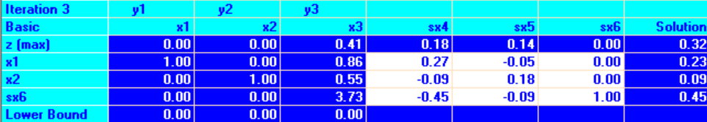

Value of Z = 0.32 therefore, V = 3.125, since Z = 1/v

Since, we have added 3 to all the entries therefore, value of game,

Therefore, optimal strategy of the two players A and B are respectively;

And the value of game

**Ques 32.**

Assume that the two firms are competing for market share for a particular product. Each firm is considering what promotional strategy to employ for the coming period. Assume that the following payoff matrix describes the increase in market share for Firm A and the decrease in market share for Firm B. Determine the optimal strategies for each firm.

|  |  |  |  |
| --- | --- | --- | --- |
|  | Firm B | | |
| Firm A | No Promotion | Moderate Promotion | Much Promotion |
| No Promotion | 5 | 0 | -10 |
| Moderate Promotion | 10 | 6 | 2 |
| Much Promotion | 20 | 15 | 10 |

Formulate a suitable linear programming model of the game, with respect to minimizing player B's losses and derive the optimal strategy for B.

**Solution:**

We first add a suitable number so that the value of the game is strictly positive. Adding 11 to all the entries the problem becomes:

|  |  |  |  |
| --- | --- | --- | --- |
|  | Firm B | | |
| Firm A | No Promotion | Moderate Promotion | Much Promotion |
| No Promotion | 16 | 11 | 1 |
| Moderate Promotion | 21 | 17 | 13 |
| Much Promotion | 31 | 26 | 21 |

The above payoff matrix will result in the following LPP:

The game for player A is to maximize v,

Subject to

The game for player B is to minimize v,

Subject to

Now, dividing each of the constraints of player A and B by and writing and the constraint can be written as:

and,

A wishes to maximize that is he wishes to

Minimize

Subject to

B wishes to minimize that is he wishes to

Maximize

Subject to

We can see that the previous two LPP’s are primal dual pair. So, if we solve any one, the solution to the other may be obtained from the optimal table of the considered problem. So, we’ll solve the last problem by simplex method using TORA:

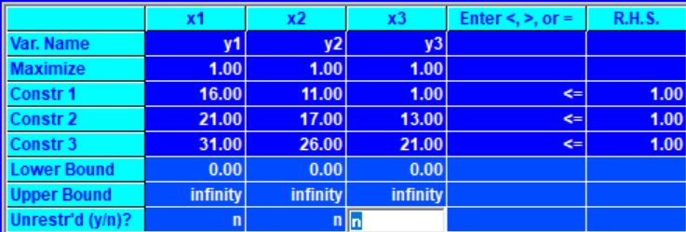

Iteration1 and Iteration2:

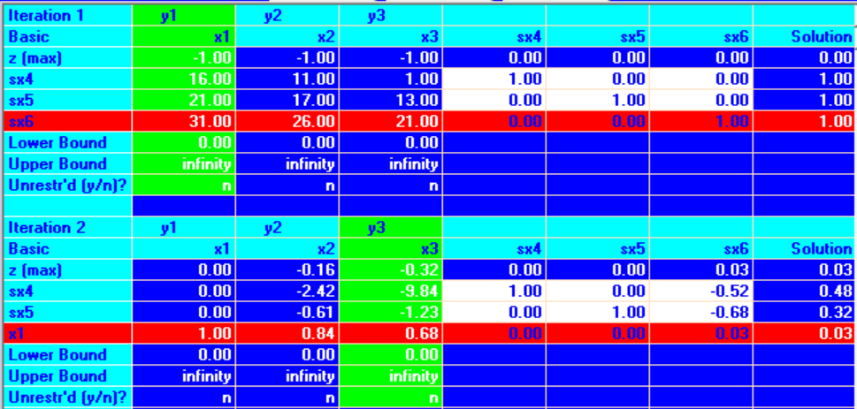

Iteration3 (Optimal):

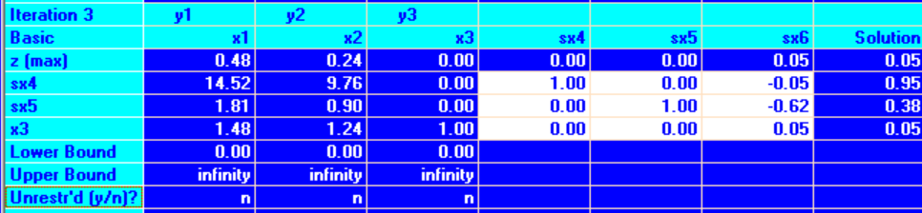

Value of Z = 0.05 therefore, V = 20, since Z = 1/v

Since, we have added 11 to all the entries therefore, value of game,

Therefore, optimal strategy of the two players A and B are respectively;

And the value of game

**Ques 33.**

Firm X is fighting for its life against the determination of firm Y to drive it out of the industry. Firm X has the choice of increasing the price, leaving it unchanged, or lowering it. Firm Y has the same three options. Firm X’s gross sales in the event of each of the pairs of choices are shown below:

|  |  |  |  |
| --- | --- | --- | --- |
| Firm Y’s Pricing Strategies | Firm Y’s Pricing Strategies | | |
| Increase Price | Do not change | Reduce Price |
| Increase Price | 90 | 80 | 110 |
| Do not change | 110 | 100 | 90 |
| Reduce Price | 120 | 70 | 80 |

Assuming firm X as the maximizing one, formulate and solve the problem as a linear programming problem.

**Solution:**

|  |  |  |  |
| --- | --- | --- | --- |
| Firm Y’s Pricing Strategies | Firm Y’s Pricing Strategies | | |
| Increase Price | Do not change | Reduce Price |
| Increase Price | 90 | 80 | 110 |
| Do not change | 110 | 100 | 90 |
| Reduce Price | 120 | 70 | 80 |

The above payoff matrix will result in the following LPP:

The game for player A is to maximize v,

Subject to

The game for player B is to minimize v,

Subject to

Now, dividing each of the constraints of player A and B by and writing and the constraint can be written as:

and,

A wishes to maximize that is he wishes to

Minimize

Subject to

B wishes to minimize that is he wishes to

Maximize

Subject to

We can see that the previous two LPP’s are primal dual pair. So, if we solve any one, the solution to the other may be obtained from the optimal table of the considered problem. So, we’ll solve the last problem by simplex method using TORA:

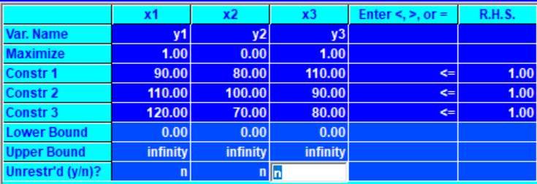

Iteration1 and Iteration2:

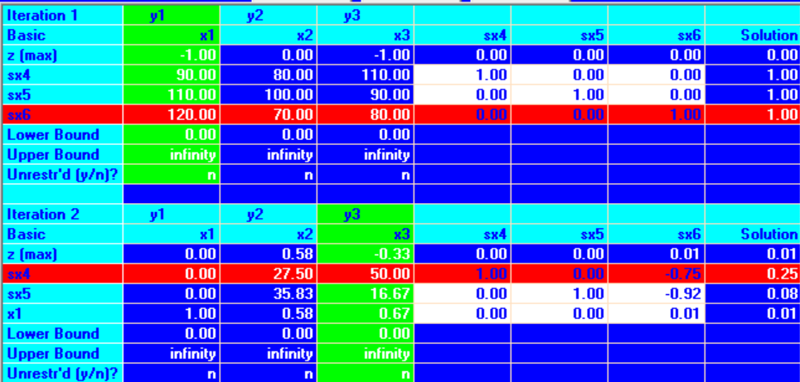

Iteration3 (Optimal):

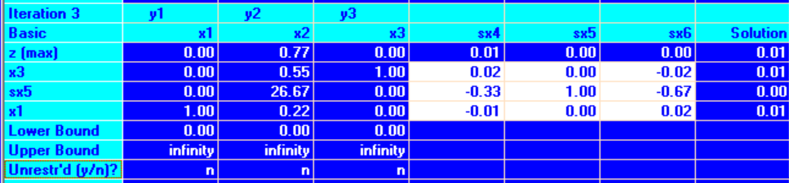

Value of Z = 0.01 therefore, V = 100, since Z = 1/v

Therefore, optimal strategy of the two players A and B are respectively;

And the value of game